**DATA MINING PROJECT REPORT**

**Prepared By: Barkha Agarwal**

**PROBLEM STATEMENT-1**

**Clustering:**

**Digital Ads Data:**

The ads24x7 is a Digital Marketing company which has now got seed funding of $10 Million. They are expanding their wings in Marketing Analytics. They collected data from their Marketing Intelligence team and now wants you (their newly appointed data analyst) to segment type of ads based on the features provided. Use Clustering procedure to segment ads into homogeneous groups.

The following three features are commonly used in digital marketing:

**CPM = (Total Campaign Spend / Number of Impressions) * 1,000**. Note that the Total Campaign Spend refers to the 'Spend' Column in the dataset and the Number of Impressions refers to the 'Impressions' Column in the dataset.

**CPC = Total Cost (spend) / Number of Clicks**.  Note that the Total Cost (spend) refers to the 'Spend' Column in the dataset and the Number of Clicks refers to the 'Clicks' Column in the dataset.

**CTR = Total Measured Clicks / Total Measured Ad Impressions x 100.** Note that the Total Measured Clicks refers to the 'Clicks' Column in the dataset and the Total Measured Ad Impressions refers to the 'Impressions' Column in the dataset.

**The Data Dictionary and the detailed description of the formulas for CPM, CPC and CTR are given in the sheet 2 of the**[Clustering Clean ads_data](https://olympus.mygreatlearning.com/courses/81614/files/6807279/download?verifier=9cHqf0pTGTKvHZ3lCWFHuL65aqhpCayisZp1Mpr9&wrap=1)**Excel File.**

Perform the following in given order:

Read the data and perform basic analysis such as printing a few rows (head and tail), info, data summary, null values duplicate values, etc.

Treat missing values in CPC, CTR and CPM using the formula given. You may refer to the [Bank_KMeans Solution File](https://olympus.mygreatlearning.com/courses/81614/files/6807289/download?wrap=1) to understand the coding behind treating the missing values using a specific formula. You have to basically create an user defined function and then call the function for imputing.

 Check if there are any outliers.

 Do you think treating outliers is necessary for K-Means clustering? Based on your judgement decide whether to treat outliers and if yes, which method to employ. (As an analyst your judgement may be different from another analyst).

Perform z-score scaling and discuss how it affects the speed of the algorithm.

Perform clustering and do the following:

Perform Hierarchical by constructing a Dendrogram using WARD and Euclidean distance.

Make Elbow plot (up to n=10) and identify optimum number of clusters for k-means algorithm.

Print silhouette scores for up to 10 clusters and identify optimum number of clusters.

Profile the ads based on optimum number of clusters using silhouette score and your domain understanding  
[Hint: Group the data by clusters and take sum or mean to identify trends in clicks, spend, revenue, CPM, CTR, & CPC based on Device Type. Make bar plots.]

Conclude the project by providing summary of your learnings.

**INTRODUCTION TO PROBLEM STATEMENT-1**

The purpose of this business report is to segment the ads into homogenous groups, here we will perform fundamental data analysis by finding the missing values, handling the outliers, scaling using z-score, performing k=means algorithm and calculating the silhouette score.

* **Read the data and perform basic analysis such as printing a few rows (head and tail), info, data summary, null values duplicate values, etc**

Firstly, we will upload the excel file and check the rows and columns using head and tail. Then we will check the shape of the data, here there are 23066 rows and 19 columns.

We will check the info which tells us that there are integer, float and object data type. We can also see that there are some missing values in columns CTR, CPM, CPC.

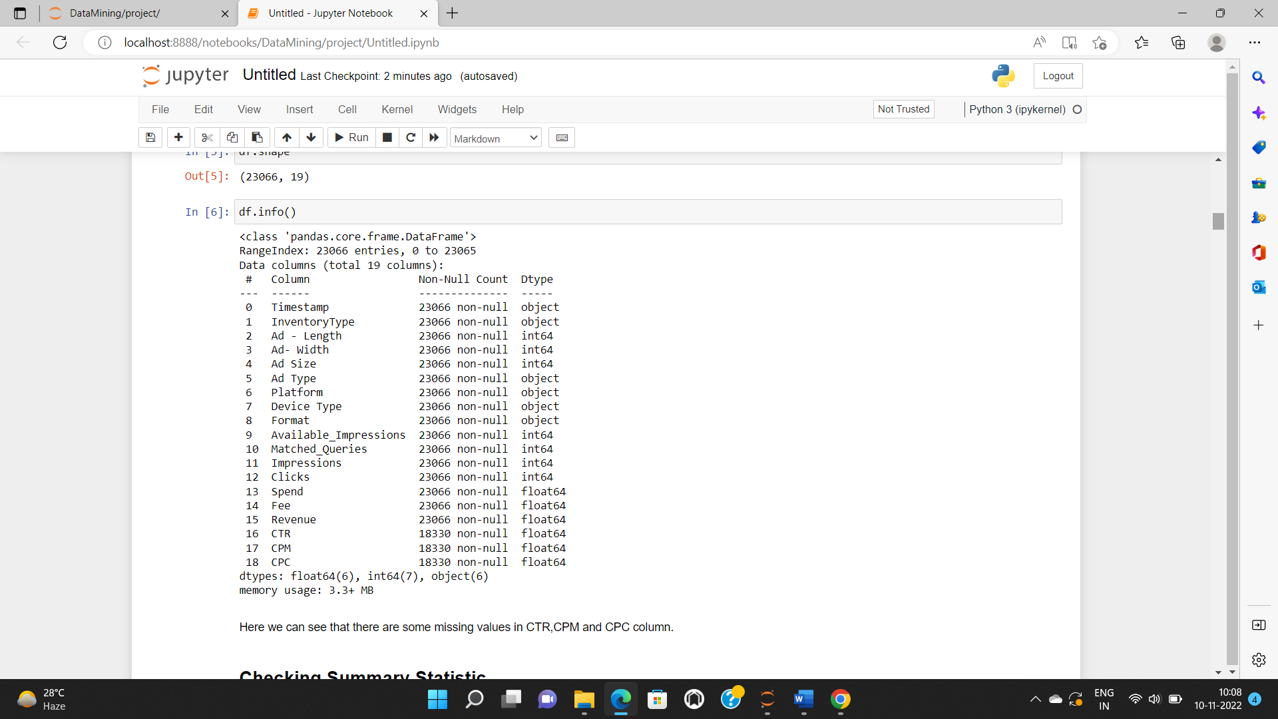

There are null values present in the dataset in columns CTR, CPM, CPC. Also, we can see that there are no duplicate values present in the dataset.

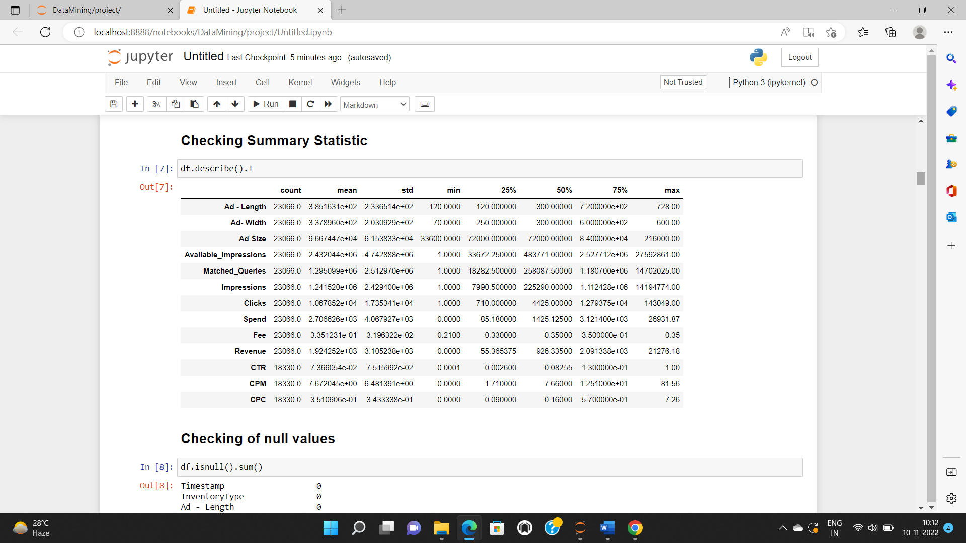

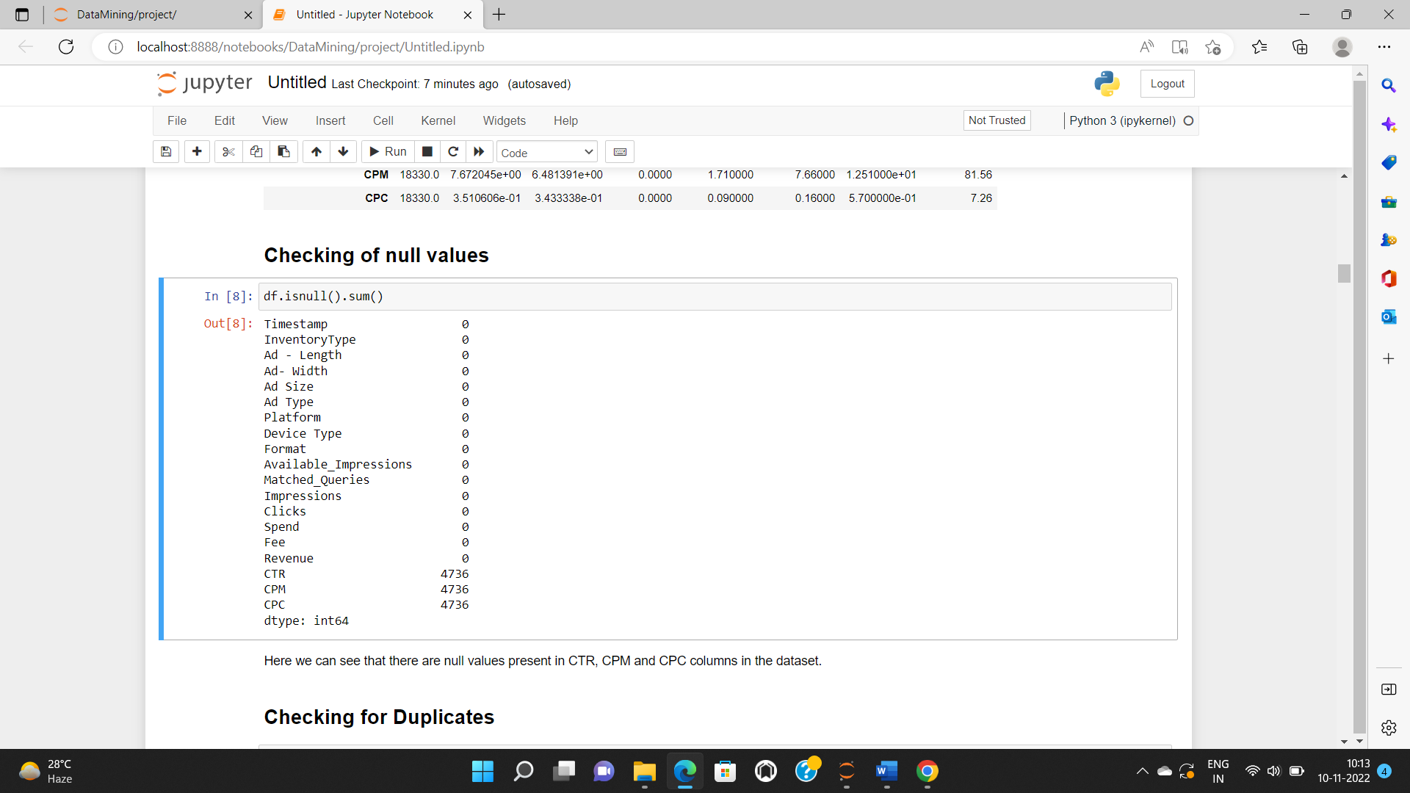

We will drop few columns from the dataset as they do not contribute for further evaluation.

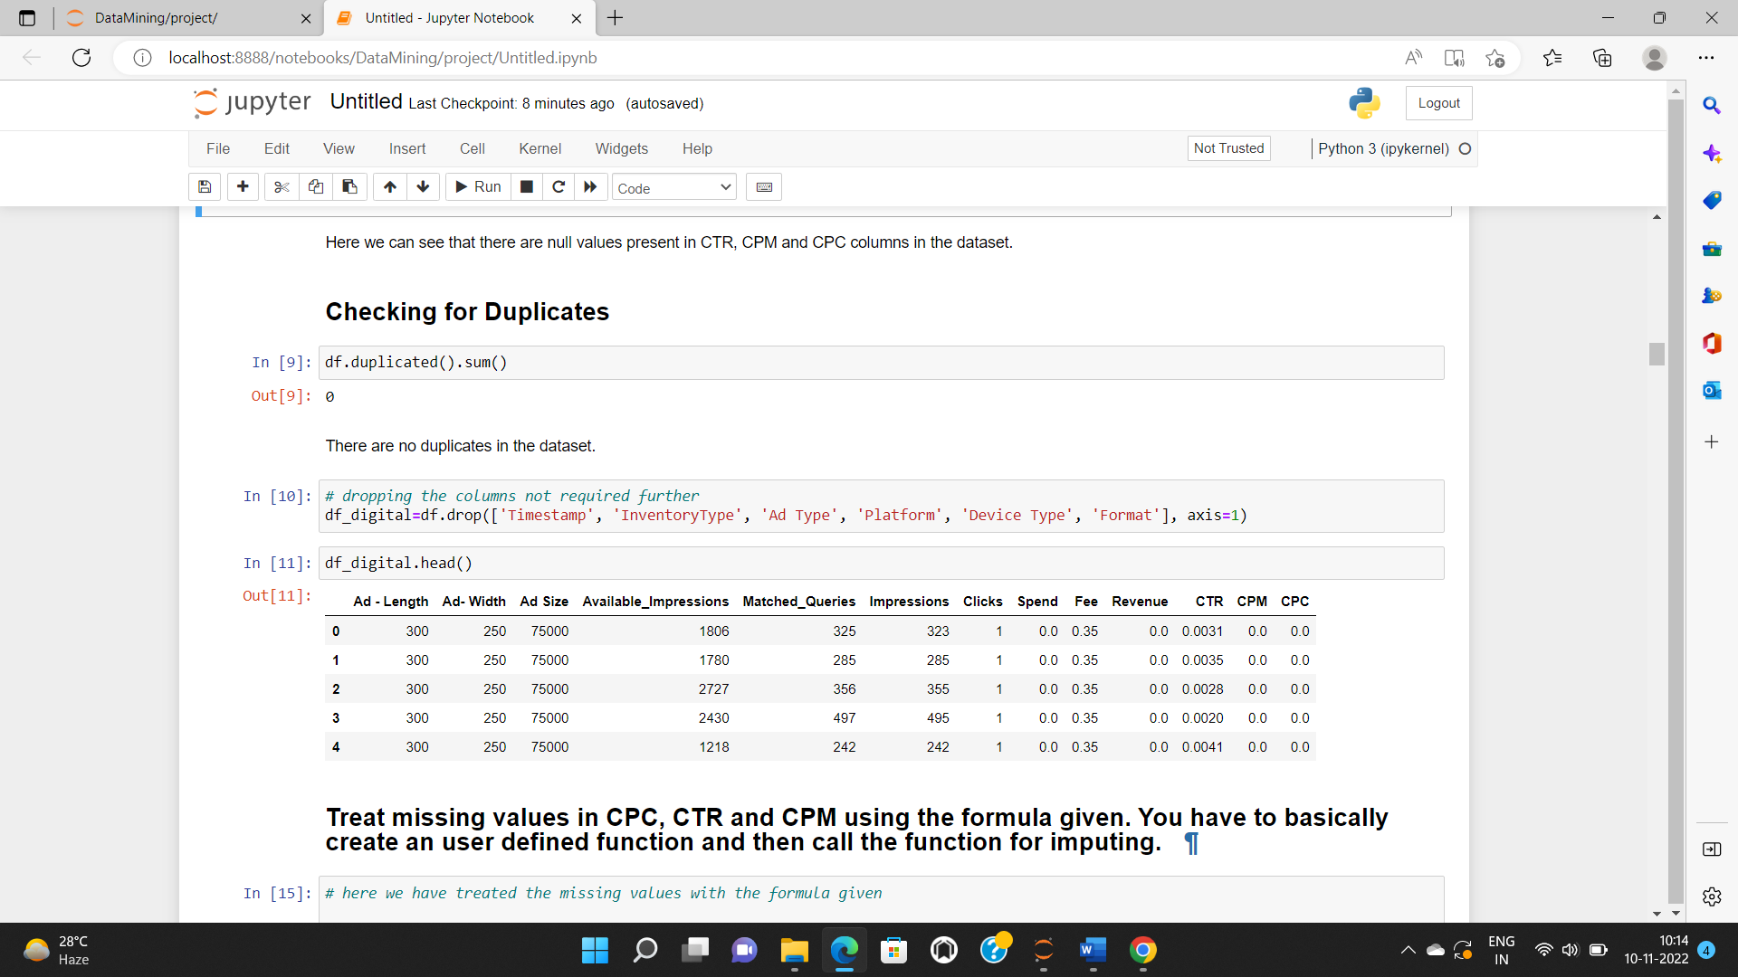

* **Treat missing values in CPC, CTR and CPM using the formula given. You have to basically create an user defined function and then call the function for imputing.**

We will treat the missing values using the fillna method and replace the missing values with the formula given.

We will check that the missing values have been treated or not.

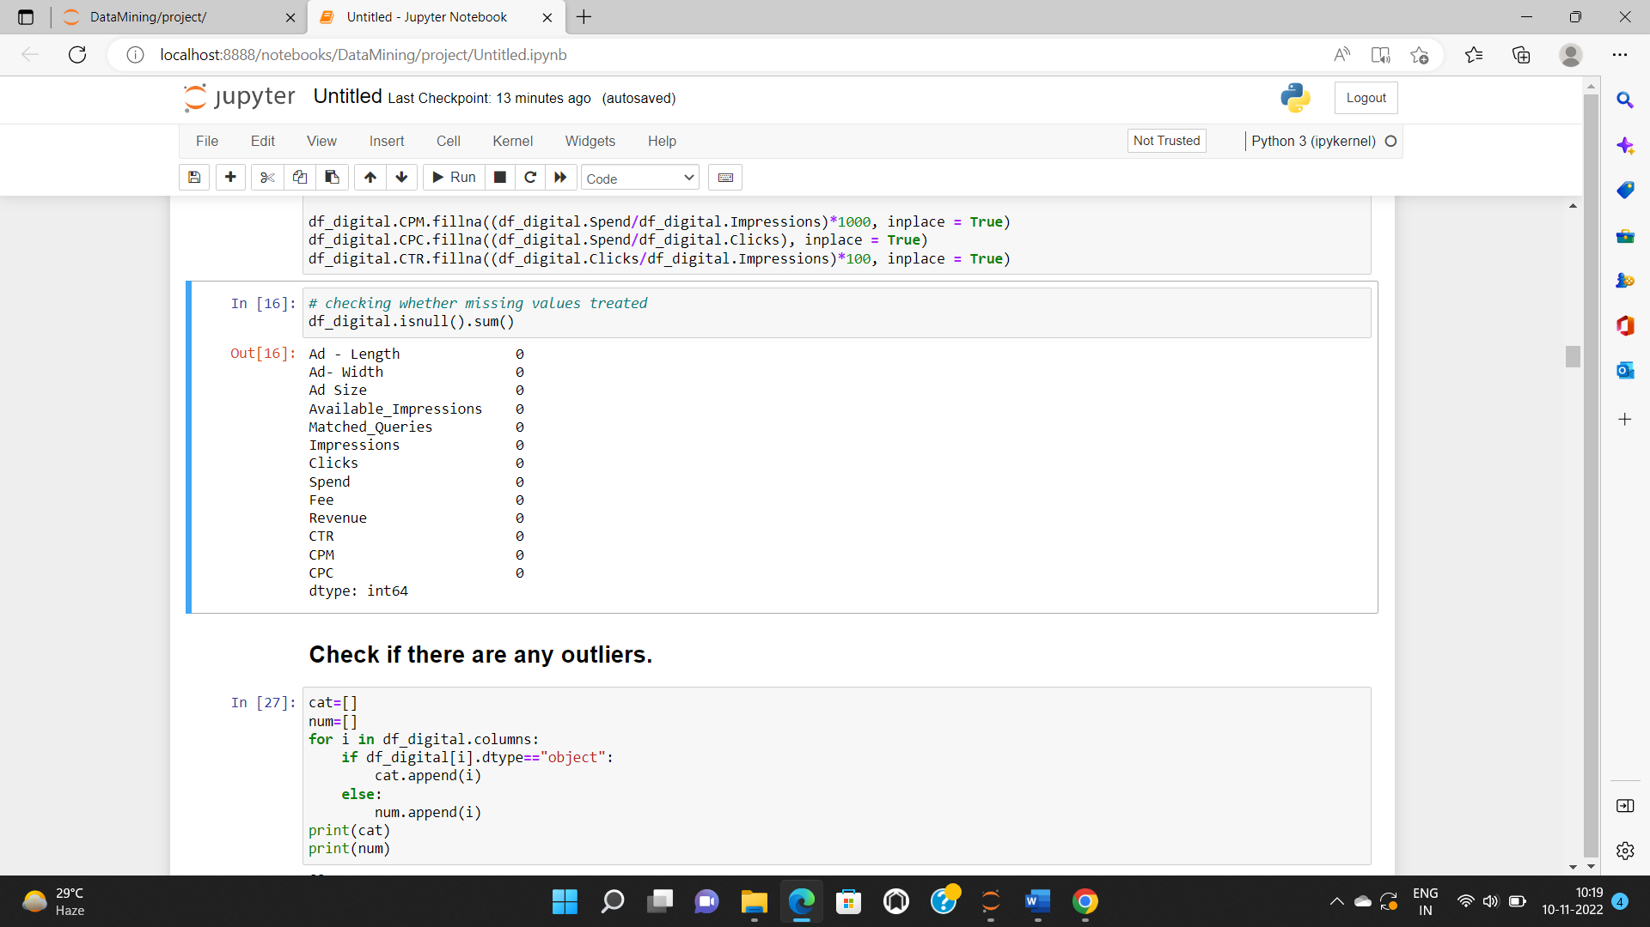

* **Check if there are any outliers.**

We can see by plotting a boxplot that there are outliers present in the dataset in 13 columns. We will create a loop here to check the boxplot of the variables. Below attached are the boxplots of the 13 variables in which we can see the outliers.

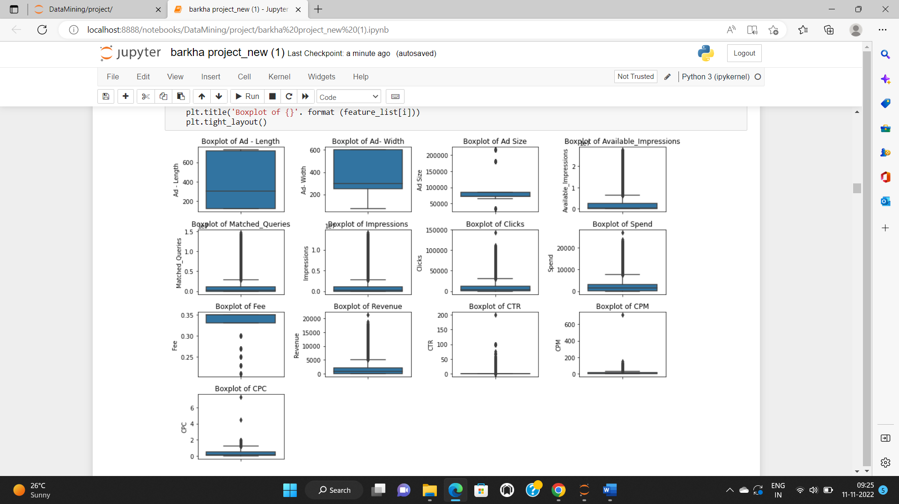

* **Do you think treating outliers is necessary for K-Means clustering? Based on your judgement decide whether to treat outliers and if yes, which method to employ. (As an analyst your judgement may be different from another analyst).**

Yes, treating the outliers is necessary for k-means clustering as it will fail to give good results if the data contains outliers and we fail to treat the outliers. In K-Means clustering outliers are found by distance based approach and cluster based approach. The goal of the project is to detect the outlier and remove the outliers to make the clustering more reliable.

Below attached is the image where boxplots have been treated.

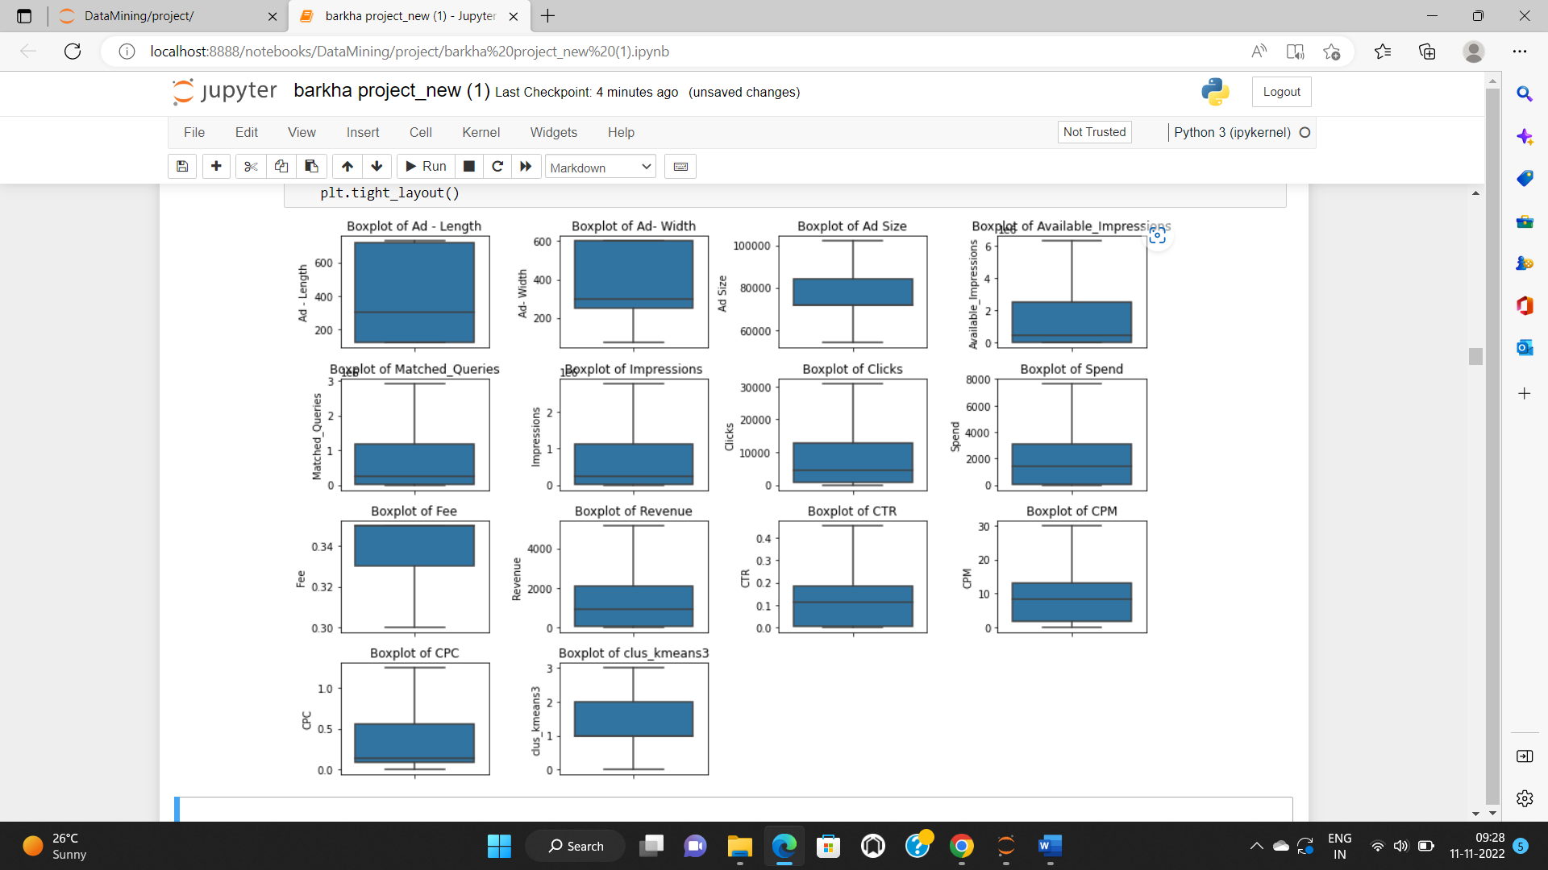

* **Perform z-score scaling and discuss how it affects the speed of the algorithm**.

For performing the z-score of the numerical variables, then we will import z-score from library and scale the data using z-score. After scaling the data using z-score we will check whether the data is scaled or not.

Below is the image of data before scaling.

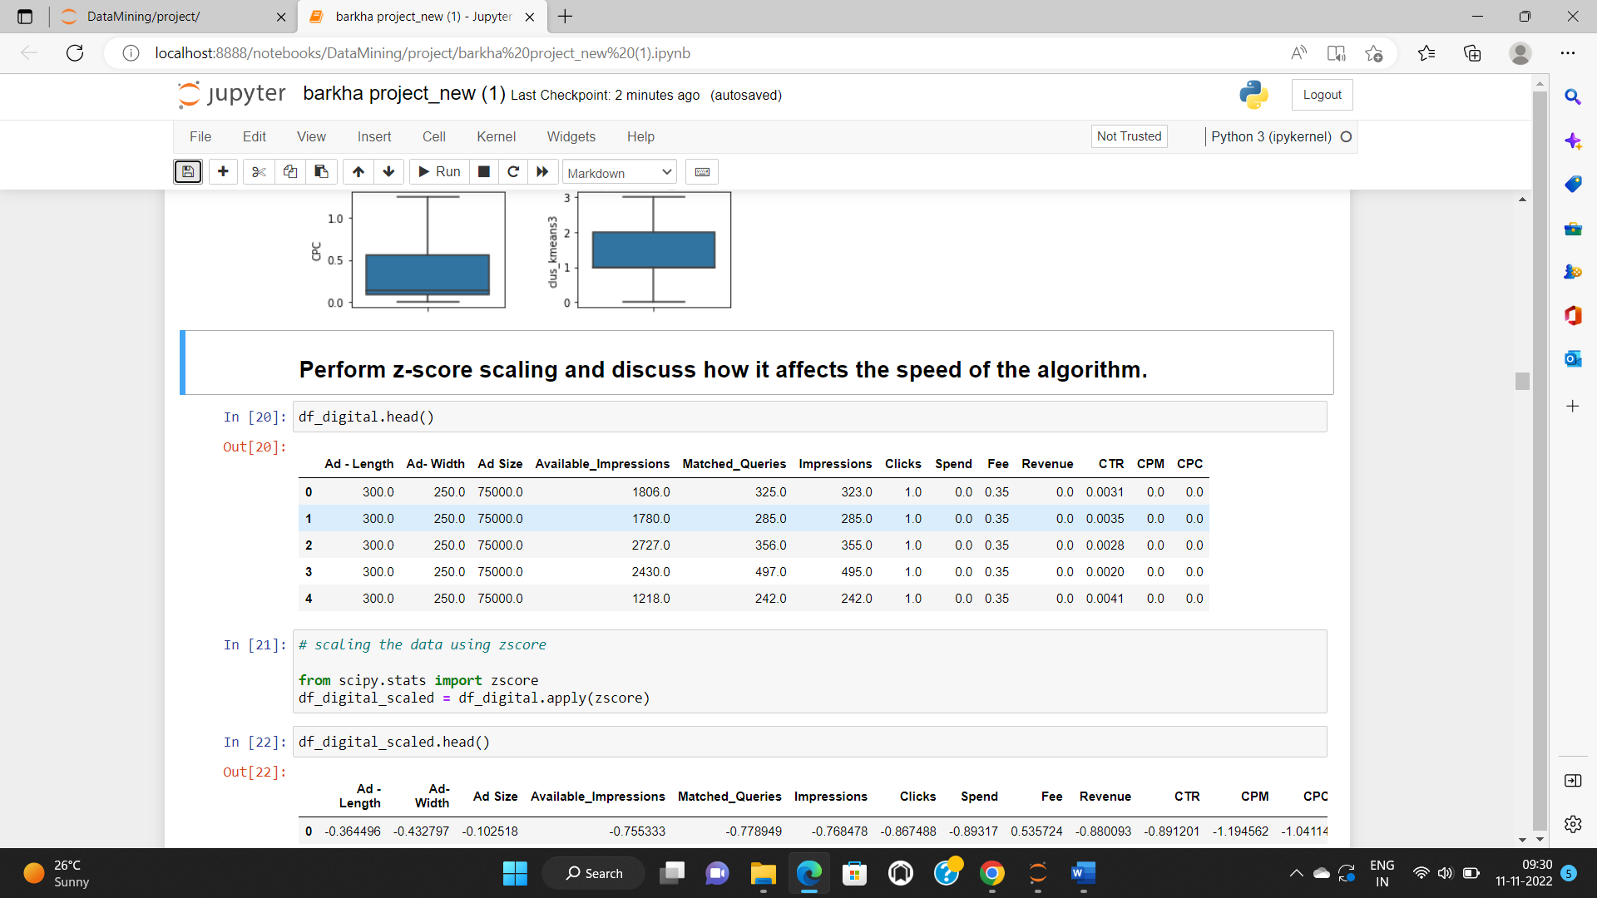

Below attached is the image after performing scaling.

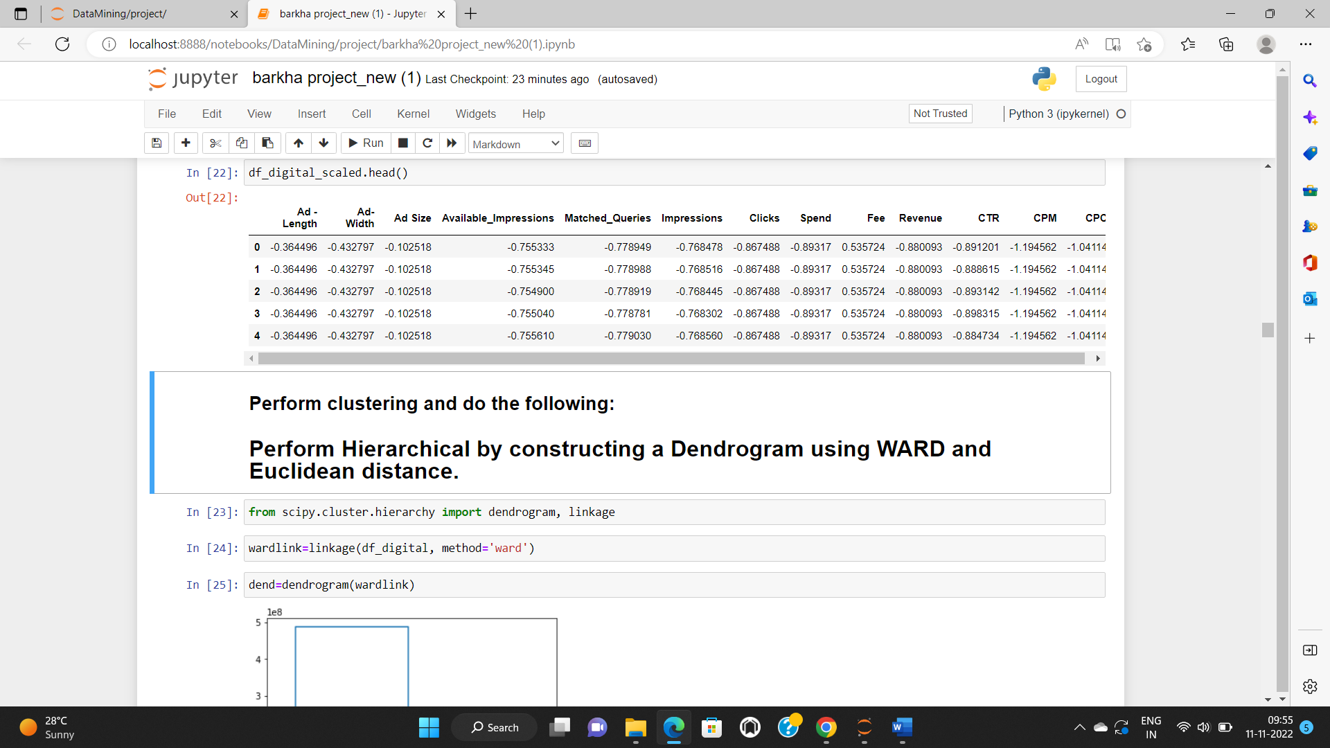

* **Perform clustering and do the following:**
* **Perform Hierarchical by constructing a Dendrogram using WARD and Euclidean distance.**

To perform the hierarchical clustering, we have to import certain packages such as dendrogram and linkage. There are two ways to proceed here but we will use the scientific python package within which we have, the dendrogram and the linkage function. Firstly, we will upload functions from the packages. Dendrogram is used for visualization and linkage is used for computing the distances and merging the clusters.

Below attached is the image of dendrogram of the data frame.

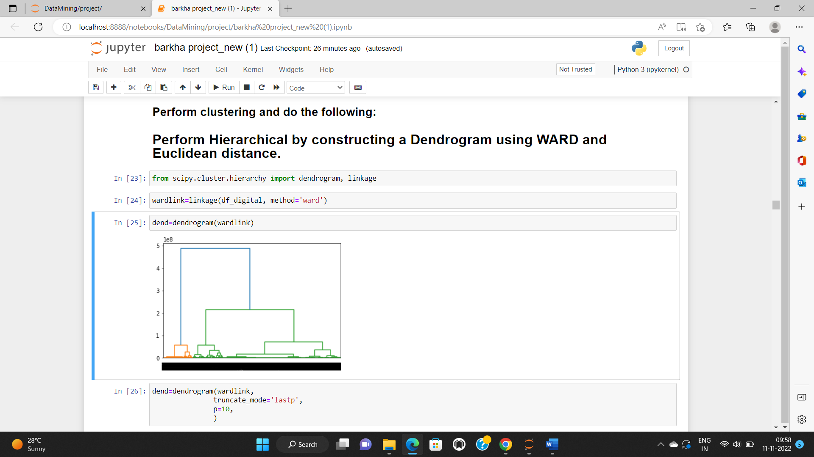

Generally, for visualization techniques too many observations are not suitable for plotting. Here we are using the truncate mode to get a clear visualization and specifying p as 10 to get the last 10 dendrograms. Each cluster has its own set of observations.

Below attached is the image of dendrogram after applying truncate mode and visualizing 10 dendrograms.

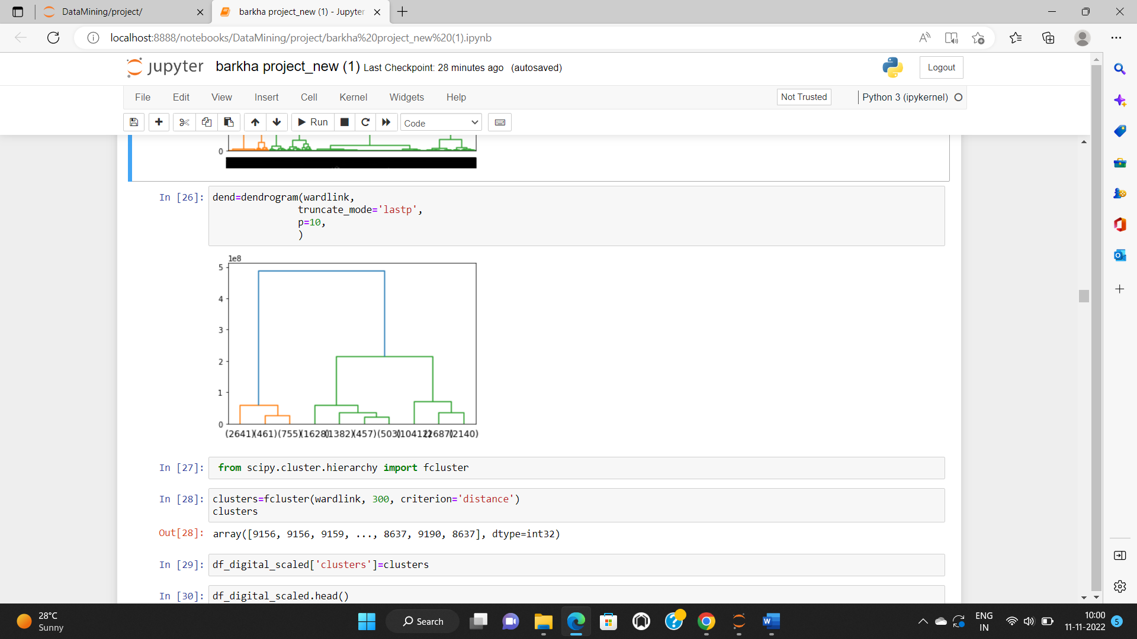

* **Make Elbow plot (up to n=10) and identify optimum number of clusters for k-means algorithm.**

As we don’t know here what is the optimum number of clusters, we will be using the WSS plot. The WSS plot is the within sum of squares plot. Here we will choose a random k value every time till n=10.

Below attached is the image of the inertia values.

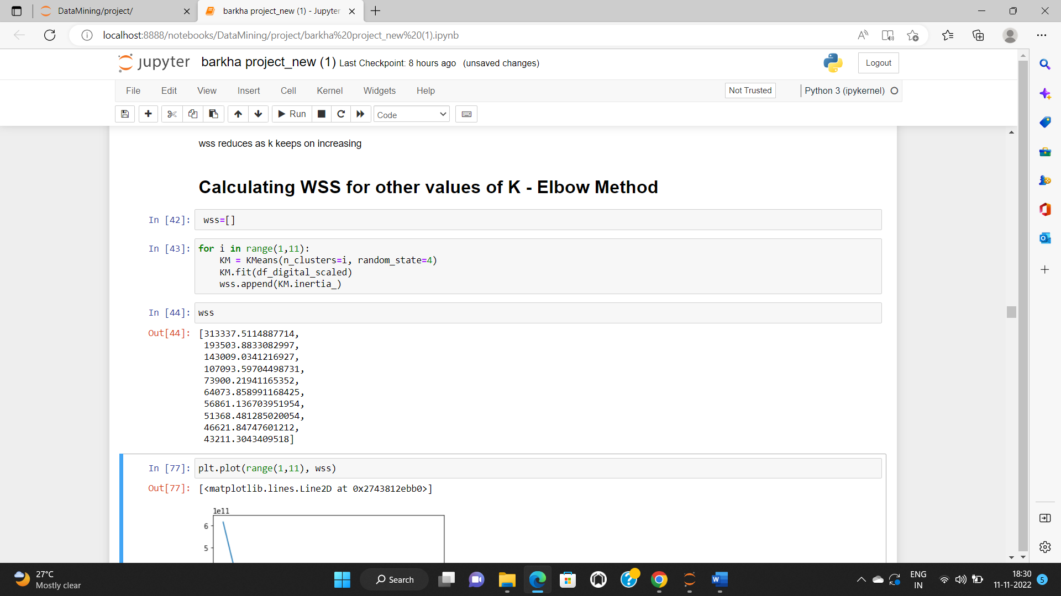

Here, we can see that the inertia values keeps on decreasing as the value of k keeps on increasing. The value has dropped significantly from cluster 1 to cluster 2. From cluster 2 to cluster 3 and cluster 3 to cluster 4 also there is a significant drop in the value, but after cluster 4, the value difference has been reduced. From this we can assume the optimum number of clusters to be 4, but before jumping into conclusion we will be visualizing this information.

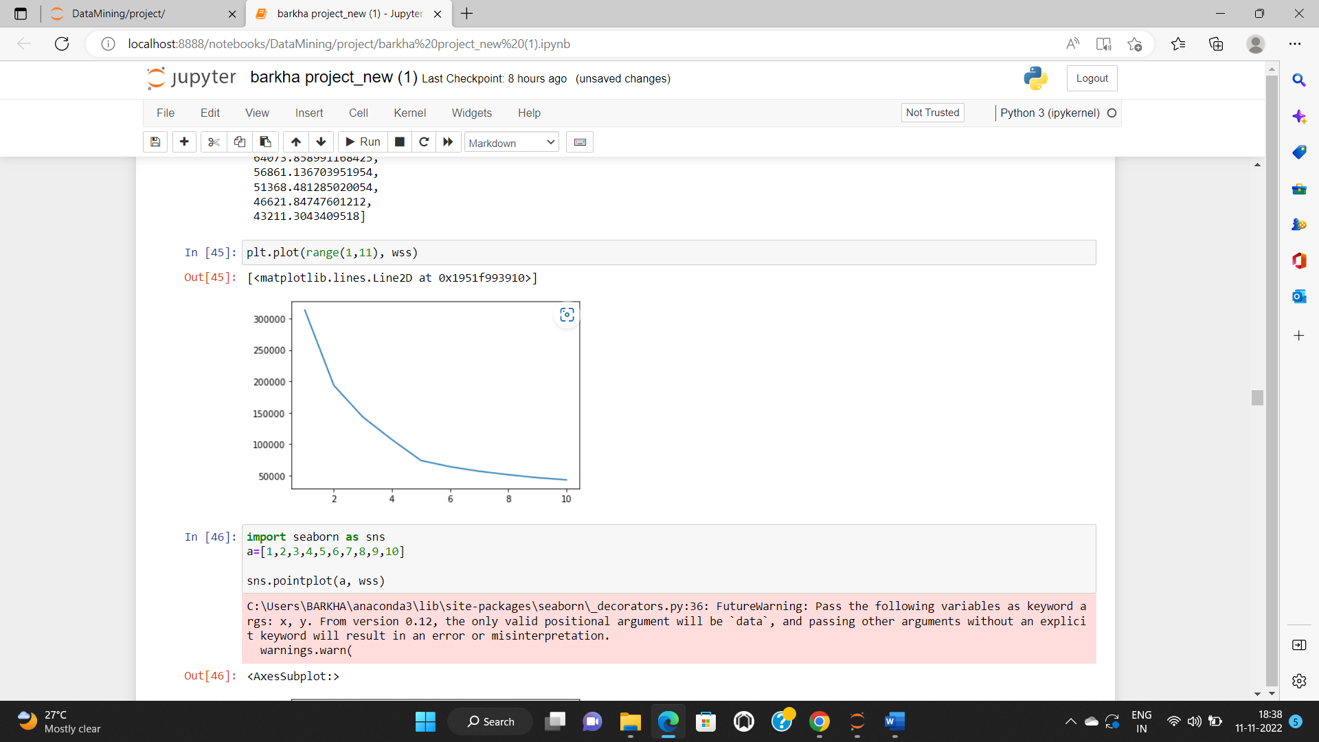

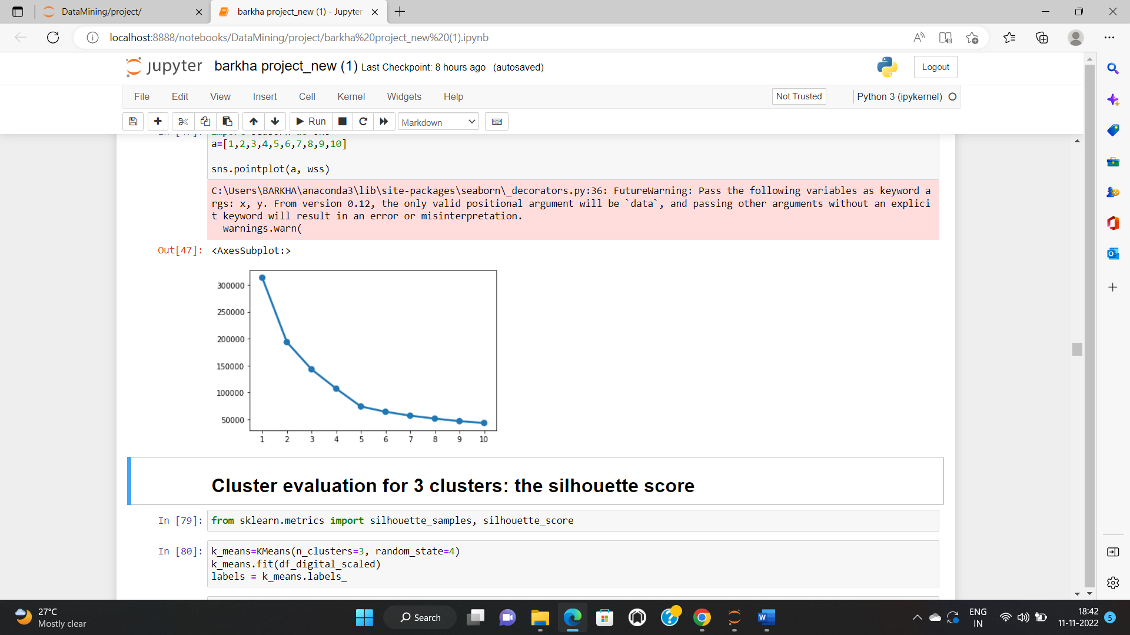

In this image the x-axis is the range which is 1 to 10 and the y-axis is the WSS.

So, from this image we can evaluate the optimum number of clusters as 4 and proceed further.

* **Print silhouette scores for up to 10 clusters and identify optimum number of clusters.**

The silhouette score function basically calculates the average of all the silhouette widths. The value of silhouette score ranges from -1 to +1. The silhouette scores is more for 4 clusters as compared to cluster 3, so the final number of optimum clusters is 4. The silhouette score for cluster 4 is 0.4068837613500353.

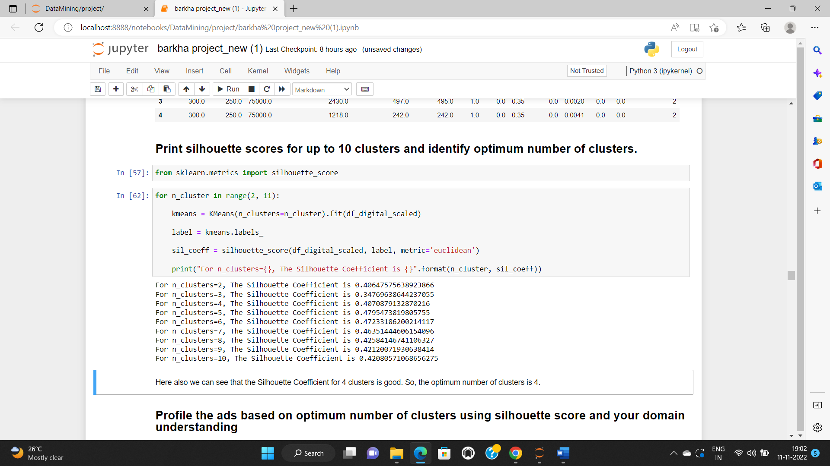

* **Profile the ads based on optimum number of clusters using silhouette score and your domain understanding**

**[Hint: Group the data by clusters and take sum or mean to identify trends in clicks, spend, revenue, CPM, CTR, & CPC based on Device Type. Make bar plots.]**

Below is the image attached showing the values in each cluster.

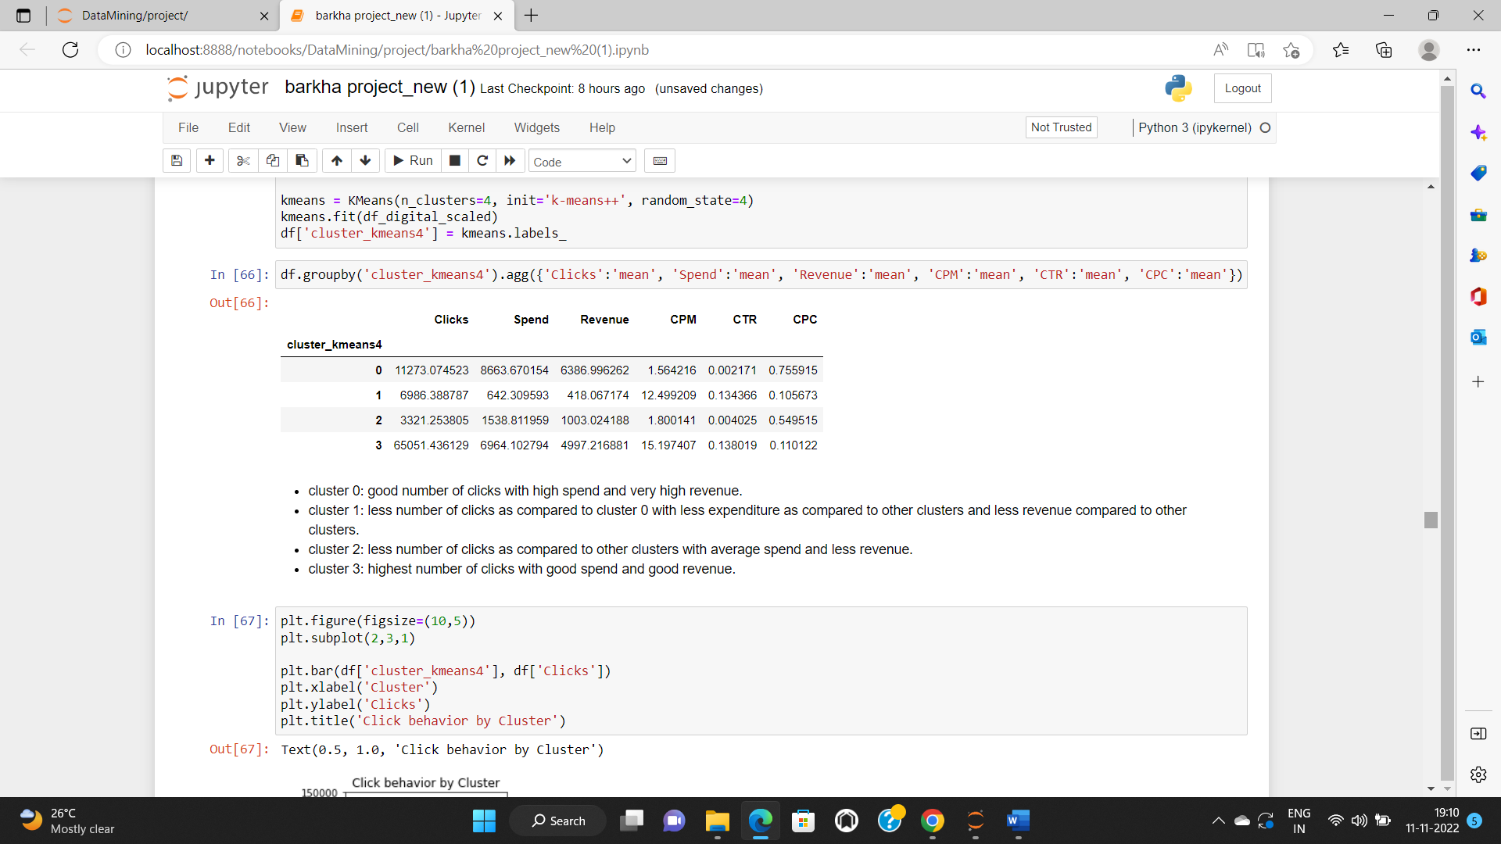

- cluster 0: good number of clicks with high spend and very high revenue.

- cluster 1: less number of clicks as compared to cluster 0 with less expenditure as compared to other clusters and less revenue compared to other clusters.

- cluster 2: less number of clicks as compared to other clusters with average spend and less revenue.

- cluster 3: highest number of clicks with good spend and good revenue.

Now we will be grouping the data by clusters and take mean to identify trends in clicks, spend, revenue, CPM, CTR, & CPC and make bar plots.

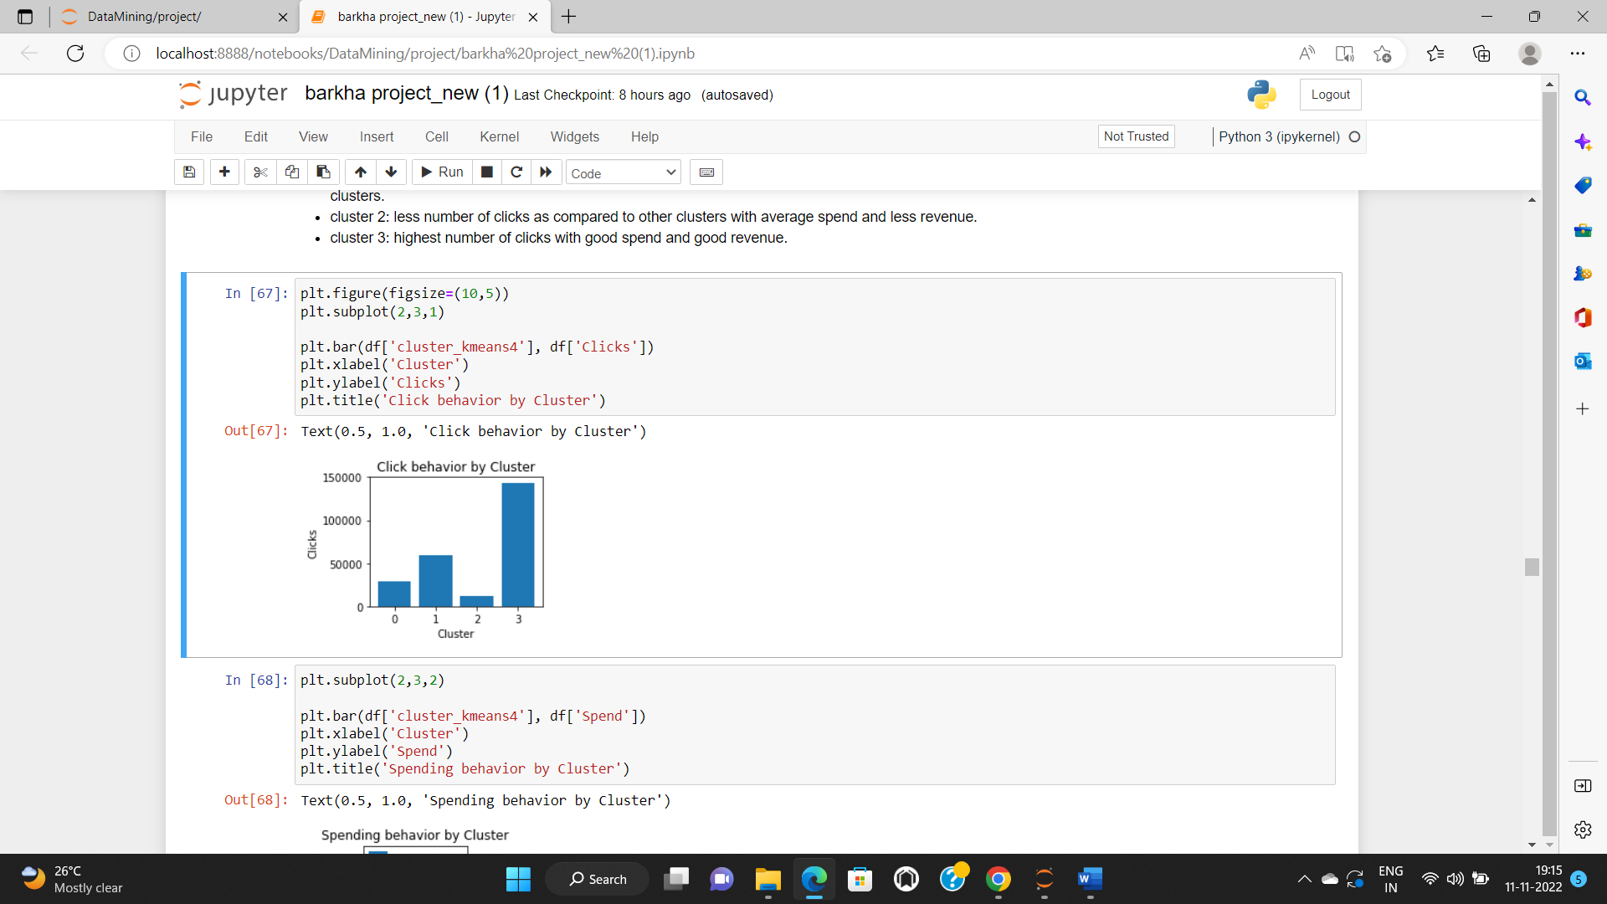 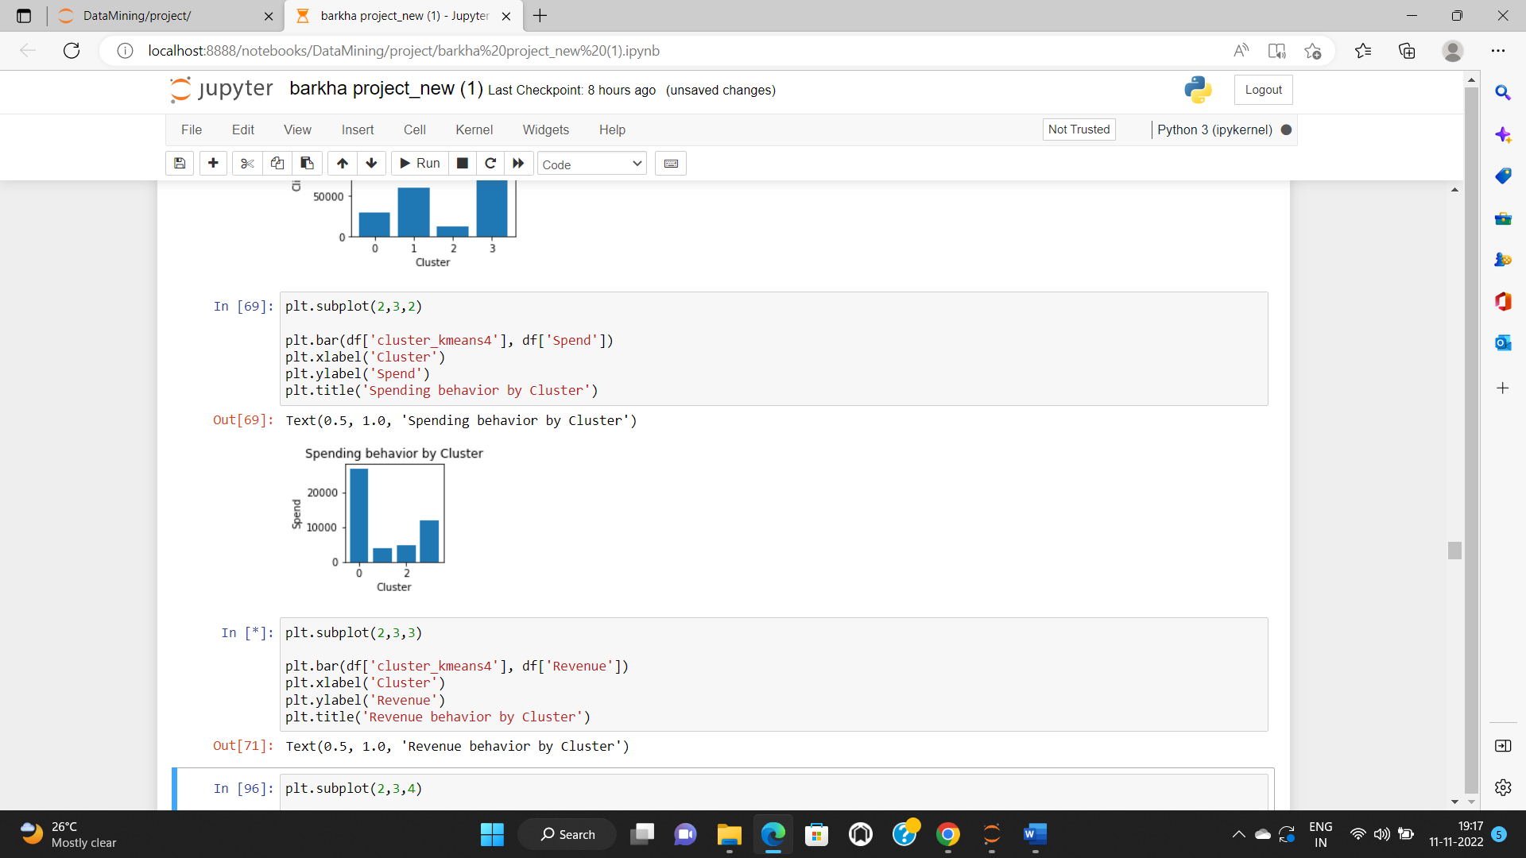

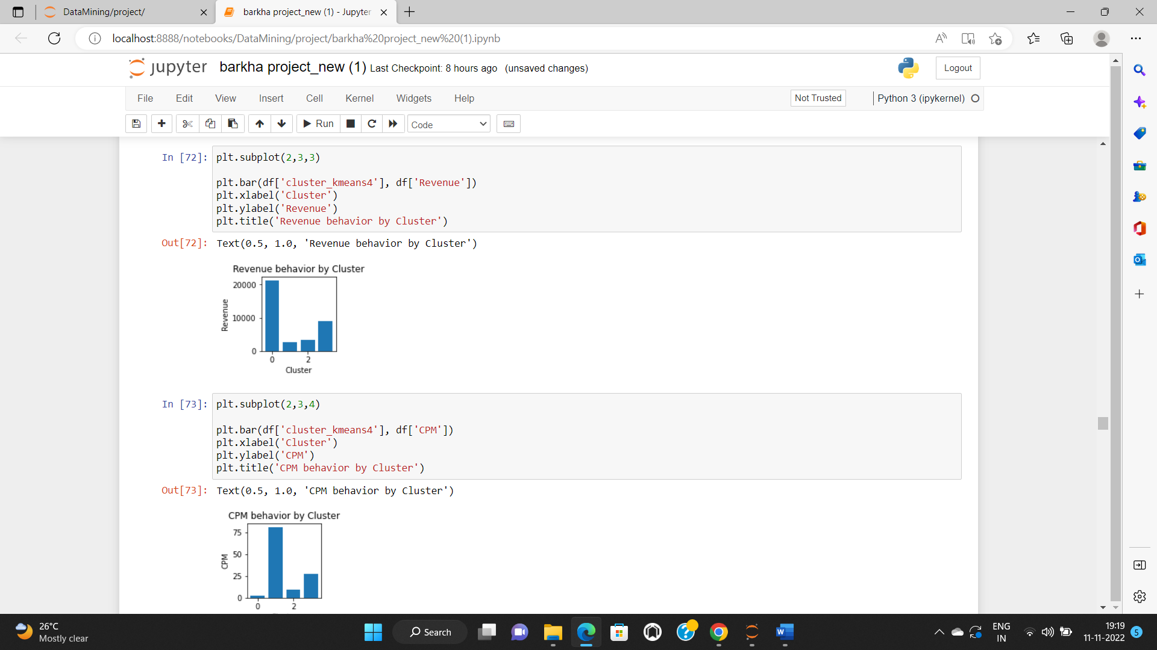 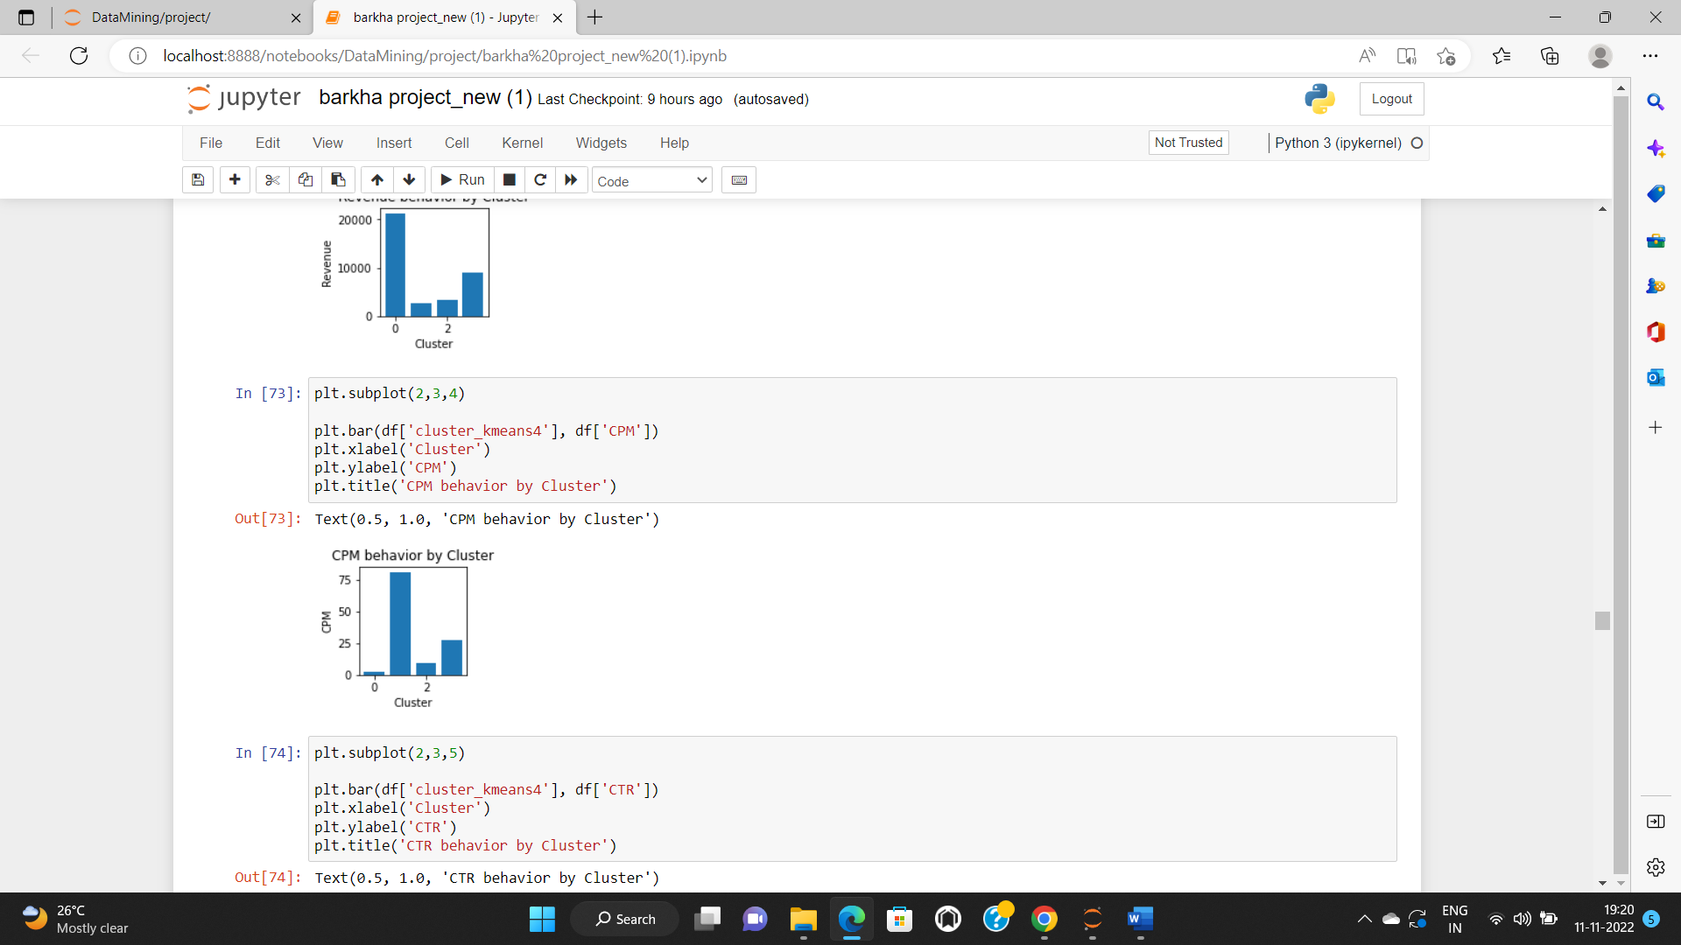

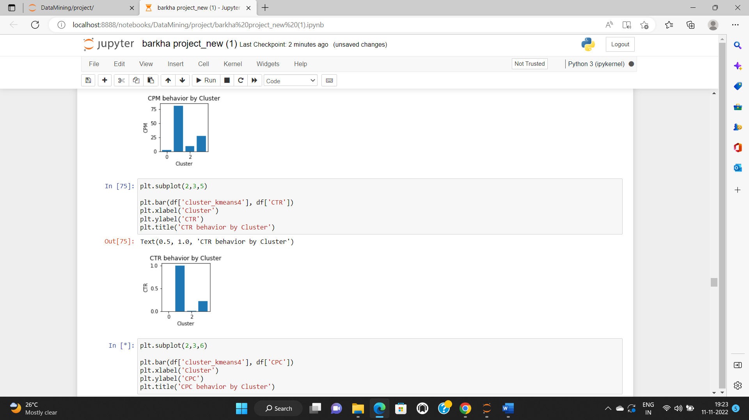 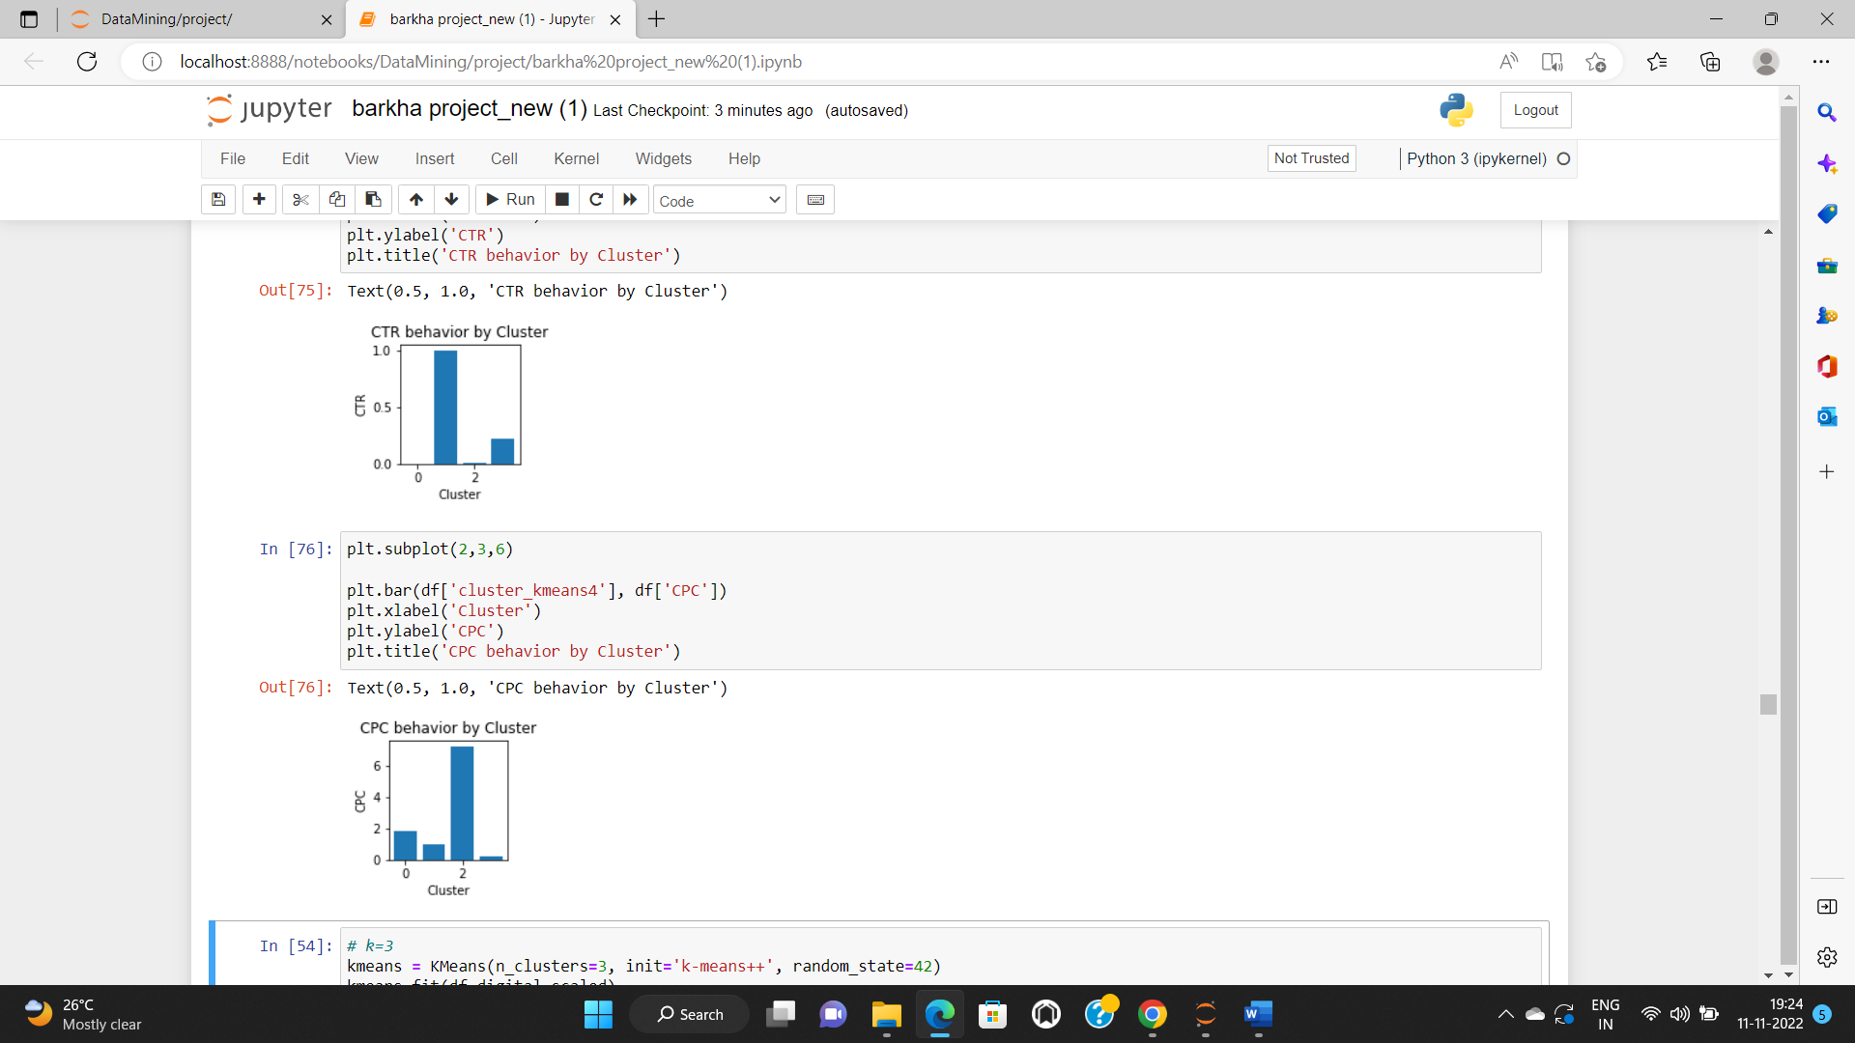

* **Conclude the project by providing summary of your learnings.**
* The dataset has 23066 rows and 19 columns.
* The missing values in CPC, CTR and CPM are treated by using the formula given and writing user defined function, and calling it.
* We check for outliers, we can see there are outliers in the variables.
* Dendrogram is the visualization and linkage is for computing the distances and merging the clusters.
* The output of Linkage is visualized by Dendrogram.
* We will create linkage using Ward’s method and run linkage function on the usable columns of the data.
* The linkage now stores the various distance at which the n clusters are sequentially merged into a single cluster.
* using fit – transform function and viewing the output - The data frame is now stored in an array.
* Using this array we can now perform k-means
* The one requirement before we run the k-means algorithm, is to know how many clusters we require as output
* We map the elbow plot using WSS values
* From the plot we have following observations:
* When we move from k=1 to k=2, we see that there is a significant drop in the value, also when we move from k=2 to k=3, k=3 to k=4 there is a significant drop as well.
* But from k=4 to k=5, k=5 to k=6, the drop in values reduces significantly.
* In other words, the WSS is not significantly dropping beyond 4,
* So, 4 is optimal number of clusters.

**PROBLEM STATEMENT-2**

**PCA:**

PCA FH (FT): Primary census abstract for female headed households excluding institutional households (India & States/UTs - District Level), Scheduled tribes - 2011 PCA for Female Headed Household Excluding Institutional Household. The Indian Census has the reputation of being one of the best in the world. The first Census in India was conducted in the year 1872. This was conducted at different points of time in different parts of the country. In 1881 a Census was taken for the entire country simultaneously. Since then, Census has been conducted every ten years, without a break. Thus, the Census of India 2011 was the fifteenth in this unbroken series since 1872, the seventh after independence and the second census of the third millennium and twenty first century. The census has been uninterruptedly continued despite of several adversities like wars, epidemics, natural calamities, political unrest, etc. The Census of India is conducted under the provisions of the Census Act 1948 and the Census Rules, 1990. The Primary Census Abstract which is important publication of 2011 Census gives basic information on Area, Total Number of Households, Total Population, Scheduled Castes, Scheduled Tribes Population, Population in the age group 0-6, Literates, Main Workers and Marginal Workers classified by the four broad industrial categories, namely, (i) Cultivators, (ii) Agricultural Laborers, (iii) Household Industry Workers, and (iv) Other Workers and also Non-Workers. The characteristics of the Total Population include Scheduled Castes, Scheduled Tribes, Institutional and Houseless Population and are presented by sex and rural-urban residence. Census 2011 covered 35 States/Union Territories, 640 districts, 5,924 sub-districts, 7,935 Towns and 6,40,867 Villages.  
The data collected has so many variables thus making it difficult to find useful details without using Data Science Techniques. You are tasked to perform detailed EDA and identify Optimum Principal Components that explains the most variance in data. Use Sklearn only.

**INTRODUCTION TO PROBLEM STATEMENT-2**

This problem statement is on PCA which is principal component analysis. The Principal Component Analysis is a popular unsupervised learning technique for reducing the dimensionality of data. It increases interpretability yet, at the same time, it minimizes information loss. It helps to find the most significant features in a dataset and makes the data easy for plotting. Here we have been given data in excel form of India data census which consists of various columns. We have to perform detailed EDA and identify Optimum Principal Components that explains the most variance in data using Sklearn.

* **Part 2 - PCA: Read the data and perform basic checks like checking head, info, summary, nulls, and duplicates, etc.**

Firstly, we will upload the excel file and check the rows and columns using head and tail. Then we will check the shape of the data, here there are 640 rows and 61 columns.

We will check the info which tells us that there are integer and object data type. We can also see that there are no missing values in any variables.

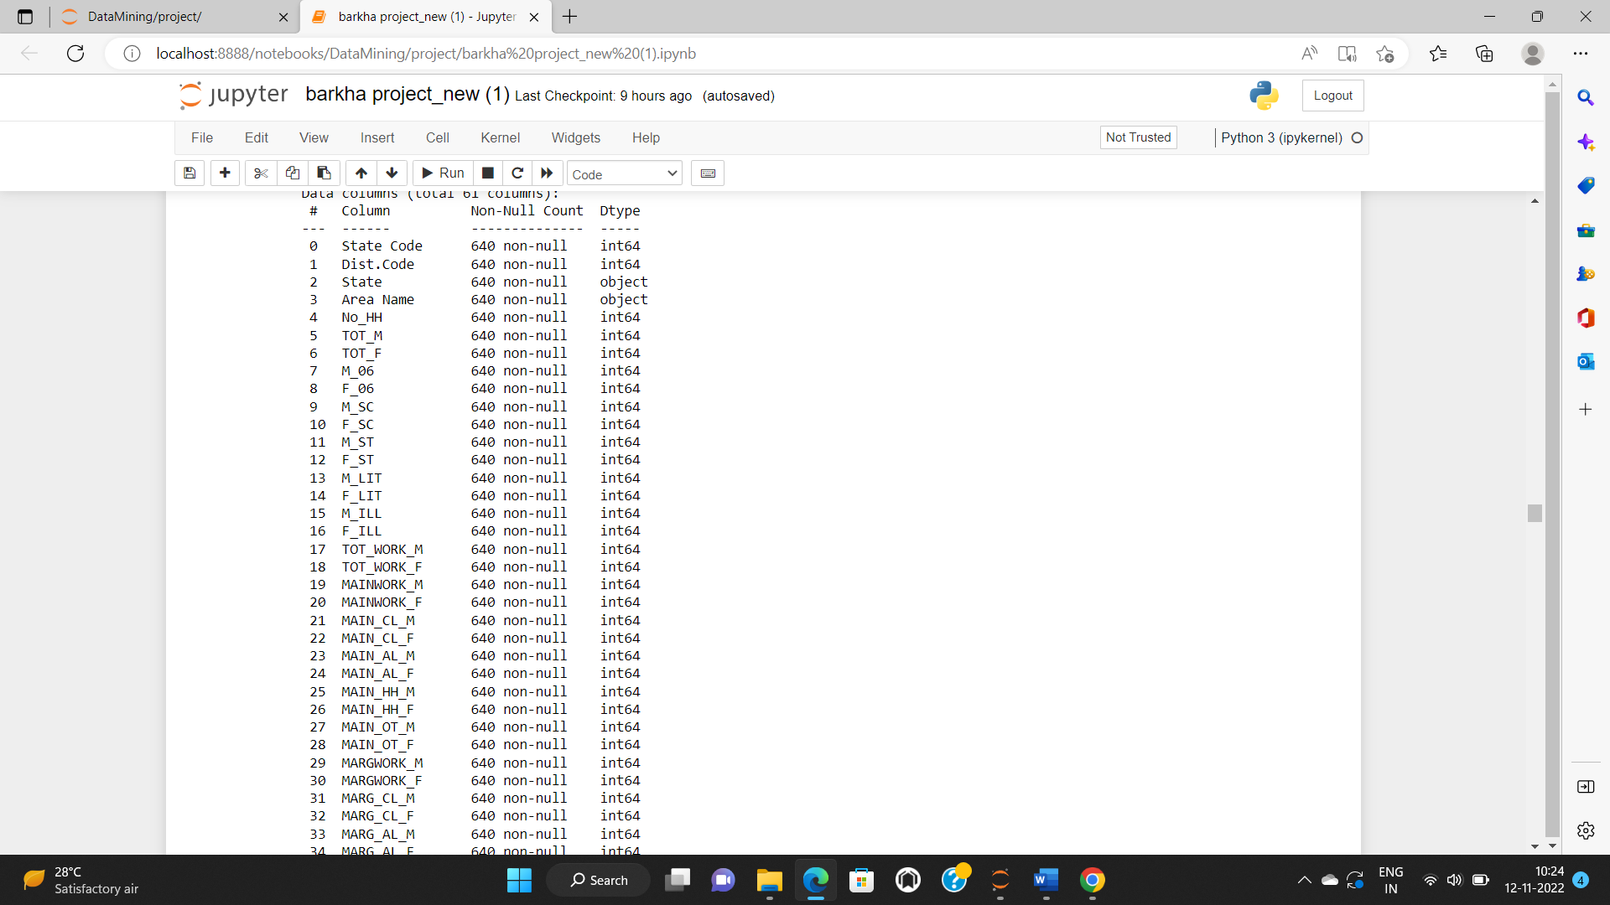

There are no missing values present in the dataset. Also, we can see that there are no duplicate values present in the dataset.

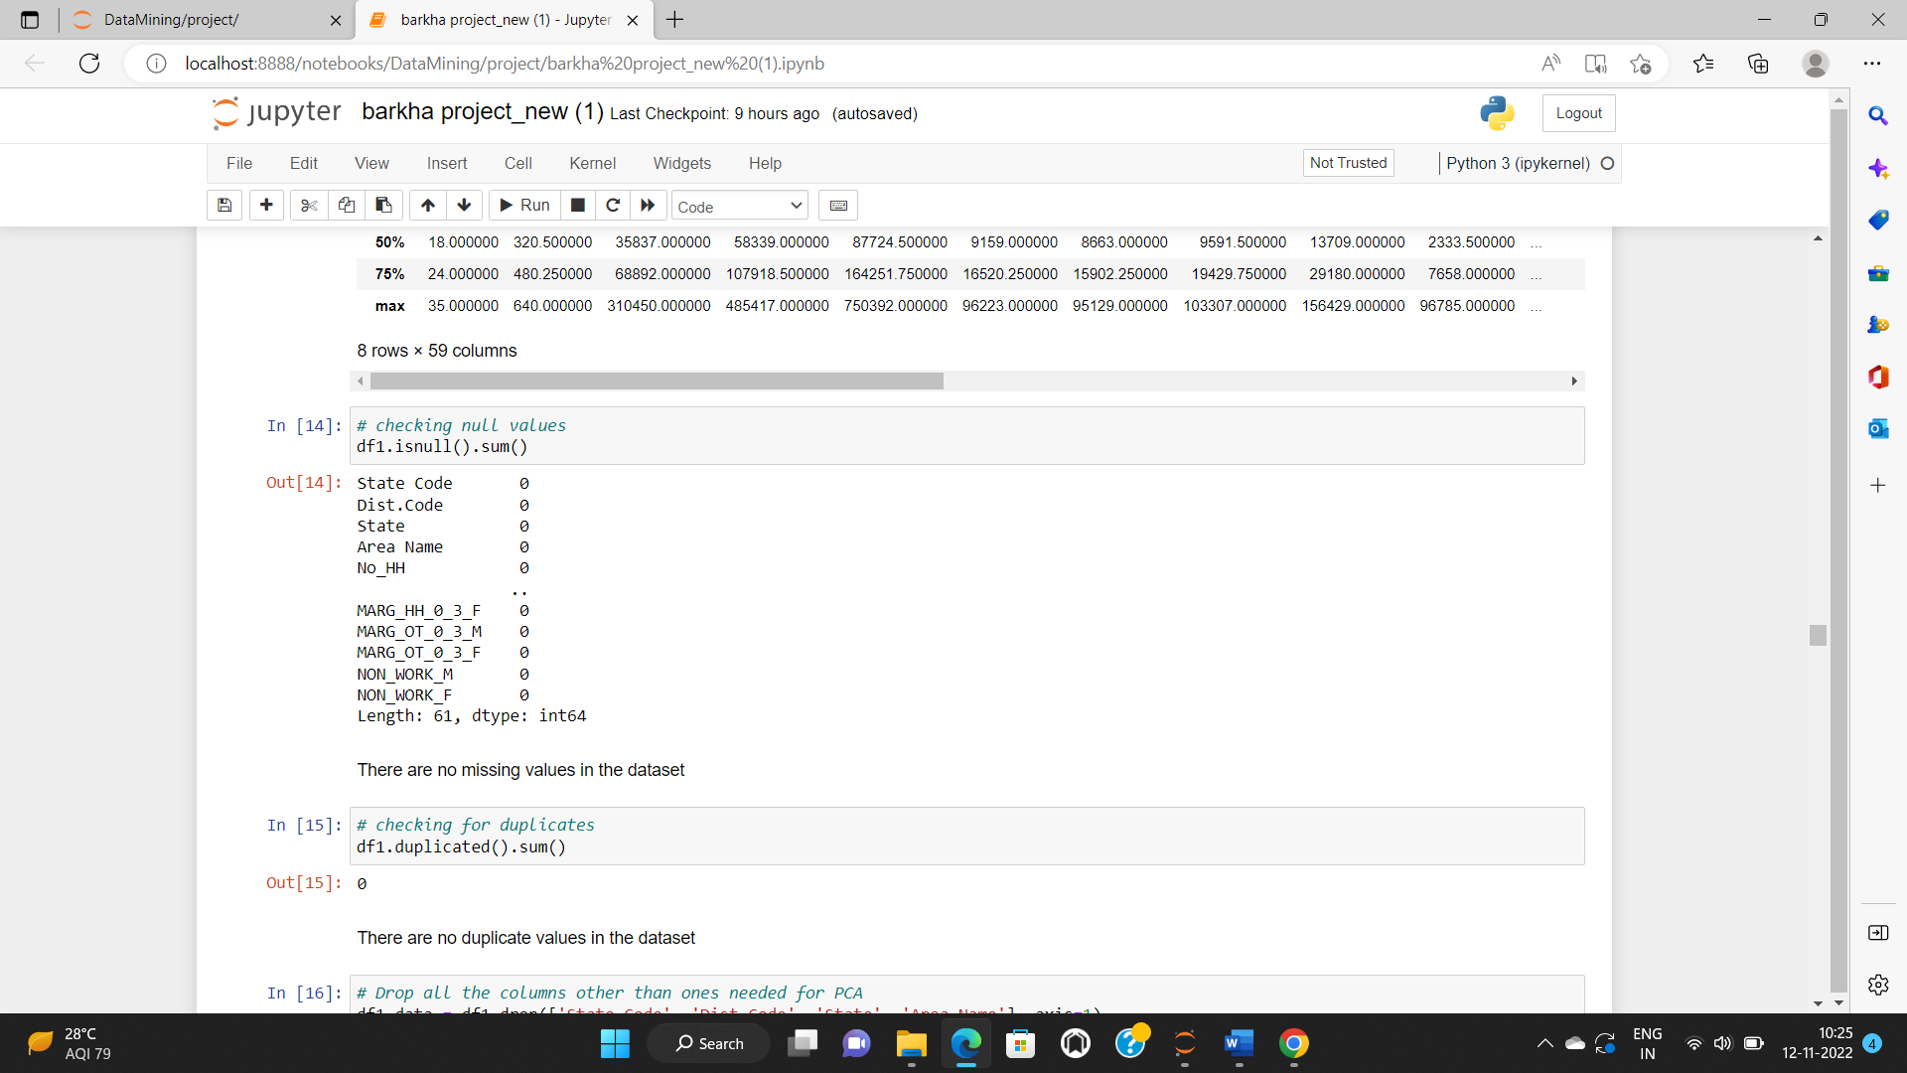

We will drop few columns from the dataset as they do not contribute for further evaluation.

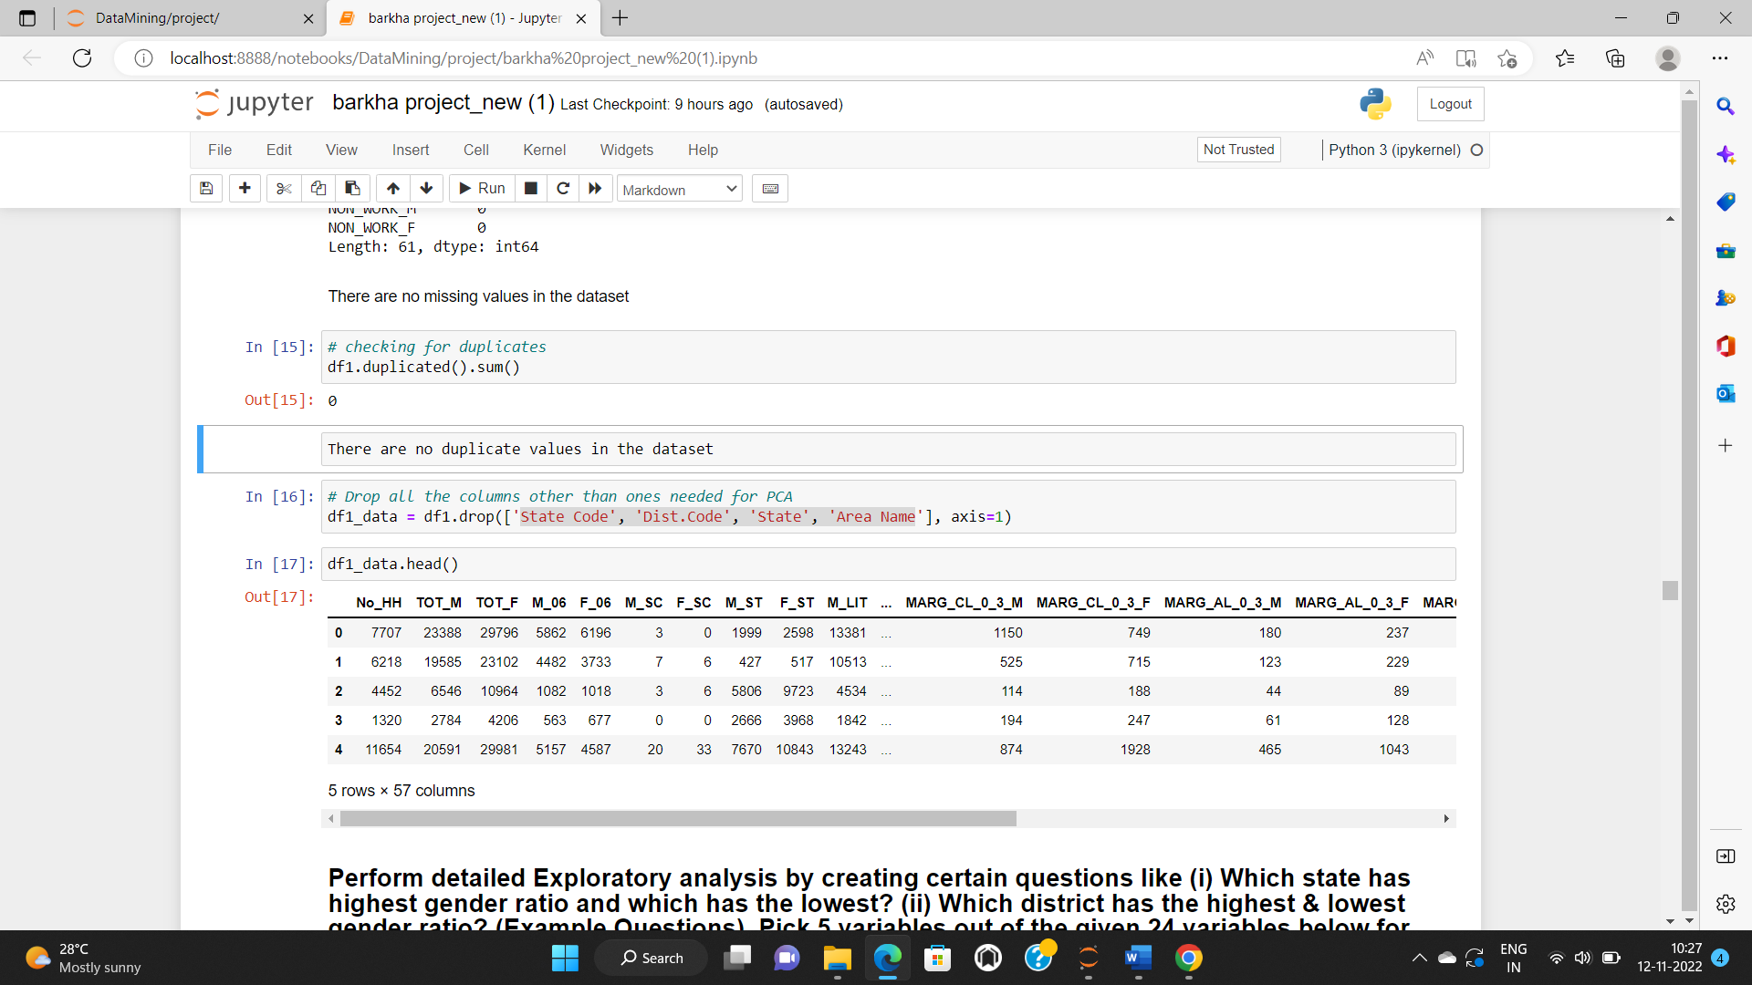

* **Part 2 - PCA: Perform detailed Exploratory analysis by creating certain questions like (i) Which state has highest gender ratio and which has the lowest? (ii) Which district has the highest & lowest gender ratio? (Example Questions). Pick 5 variables out of the given 24 variables below for EDA: No_HH, TOT_M, TOT_F, M_06, F_06, M_SC, F_SC, M_ST, F_ST, M_LIT, F_LIT, M_ILL, F_ILL, TOT_WORK_M, TOT_WORK_F, MAINWORK_M, MAINWORK_F, MAIN_CL_M, MAIN_CL_F, MAIN_AL_M, MAIN_AL_F, MAIN_HH_M, MAIN_HH_F, MAIN_OT_M, MAIN_OT_F**

For EDA 5 variables considered are No_HH, TOT_M, TOT_F, TOT_WORK_M, TOT_WORK_F.

Univariate Analysis: Plotting histogram and boxplots for the above variables.

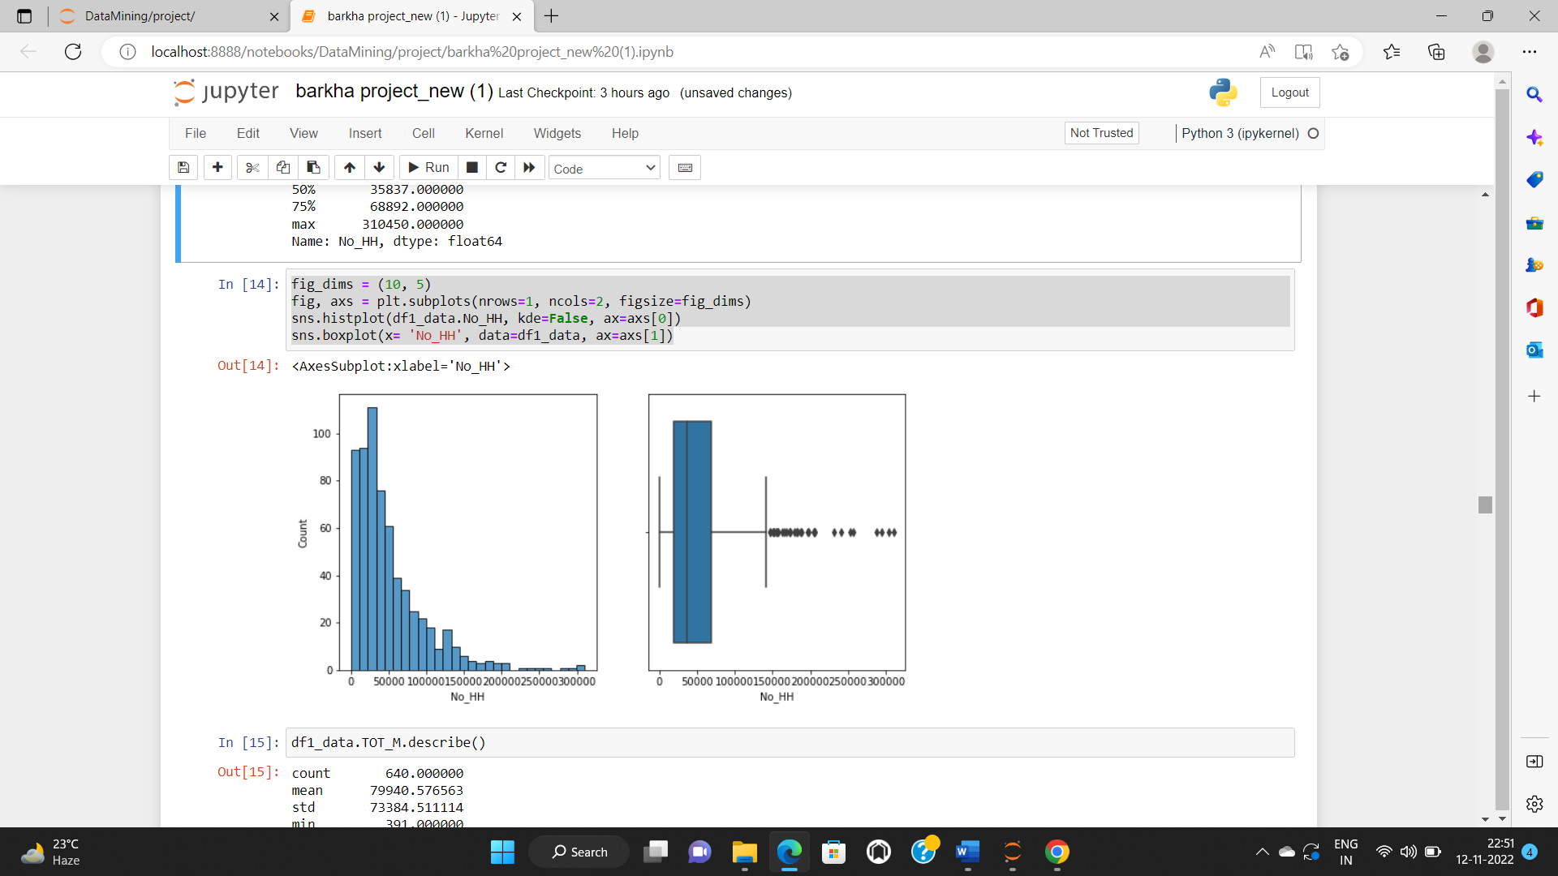

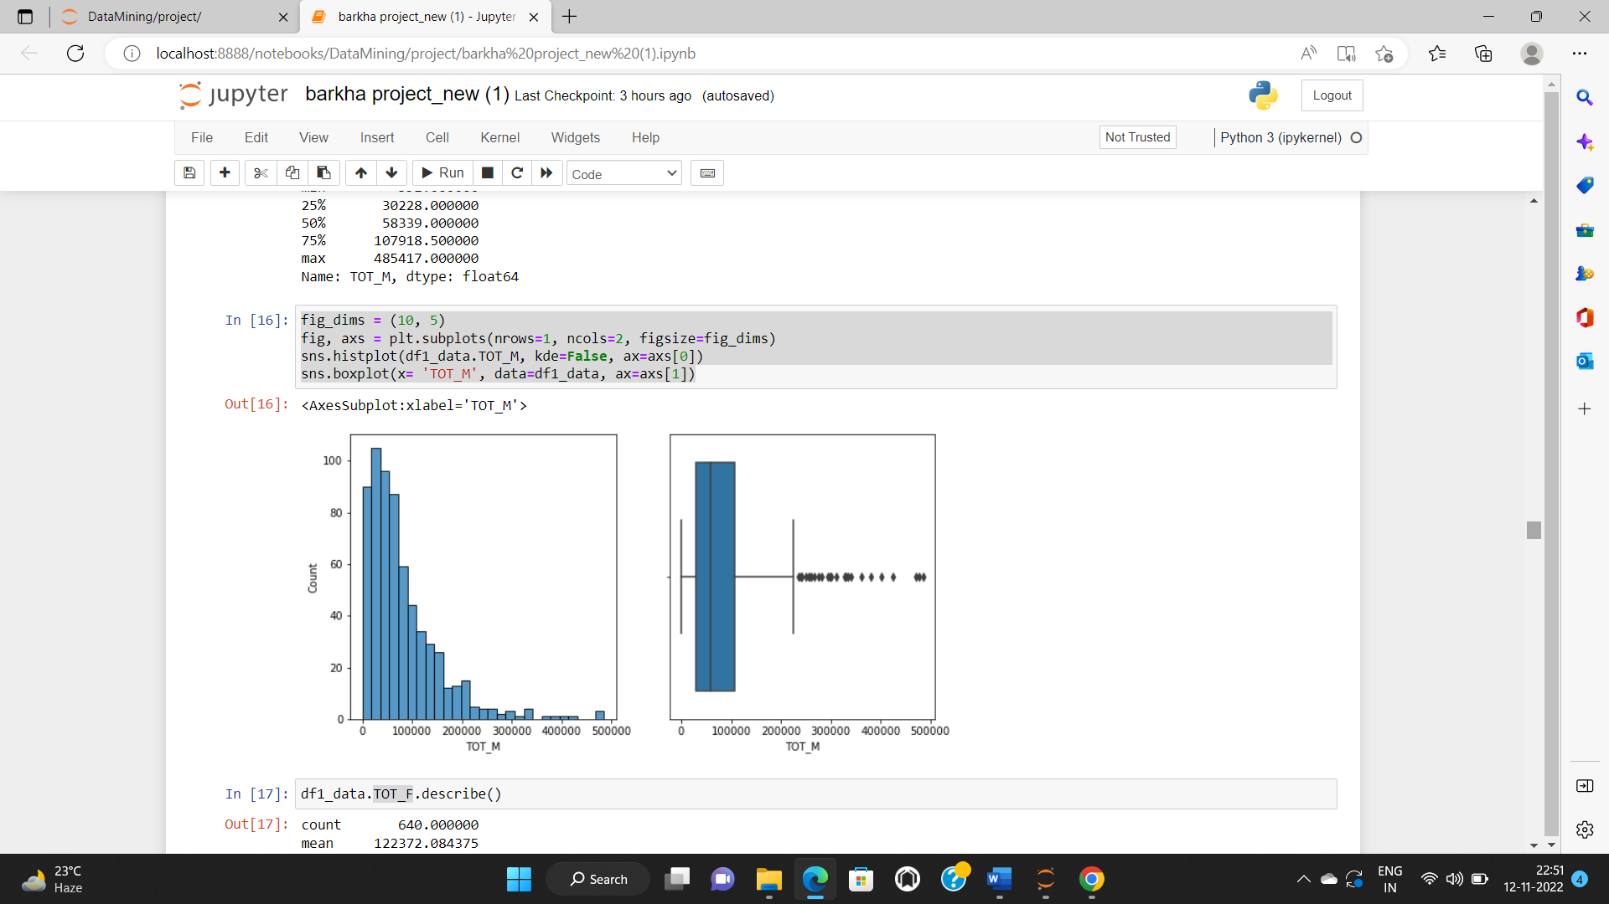

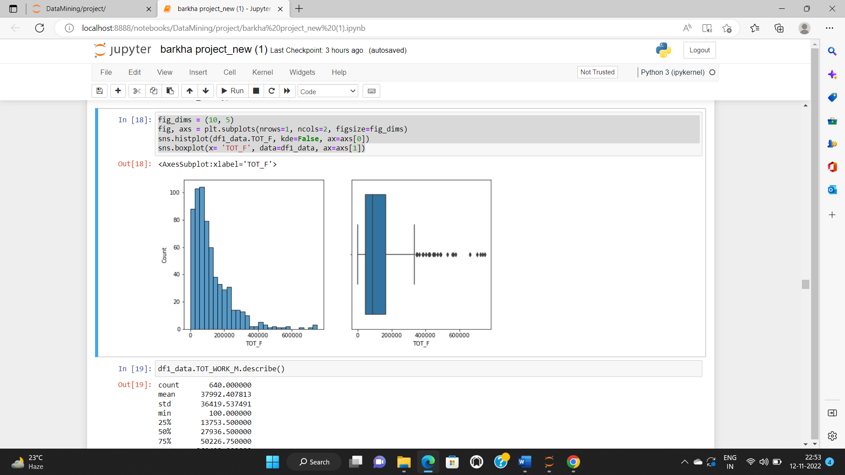

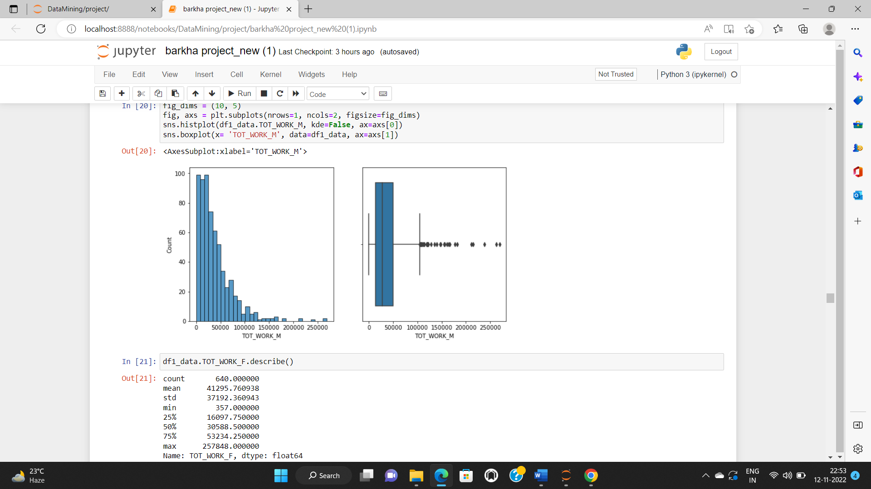

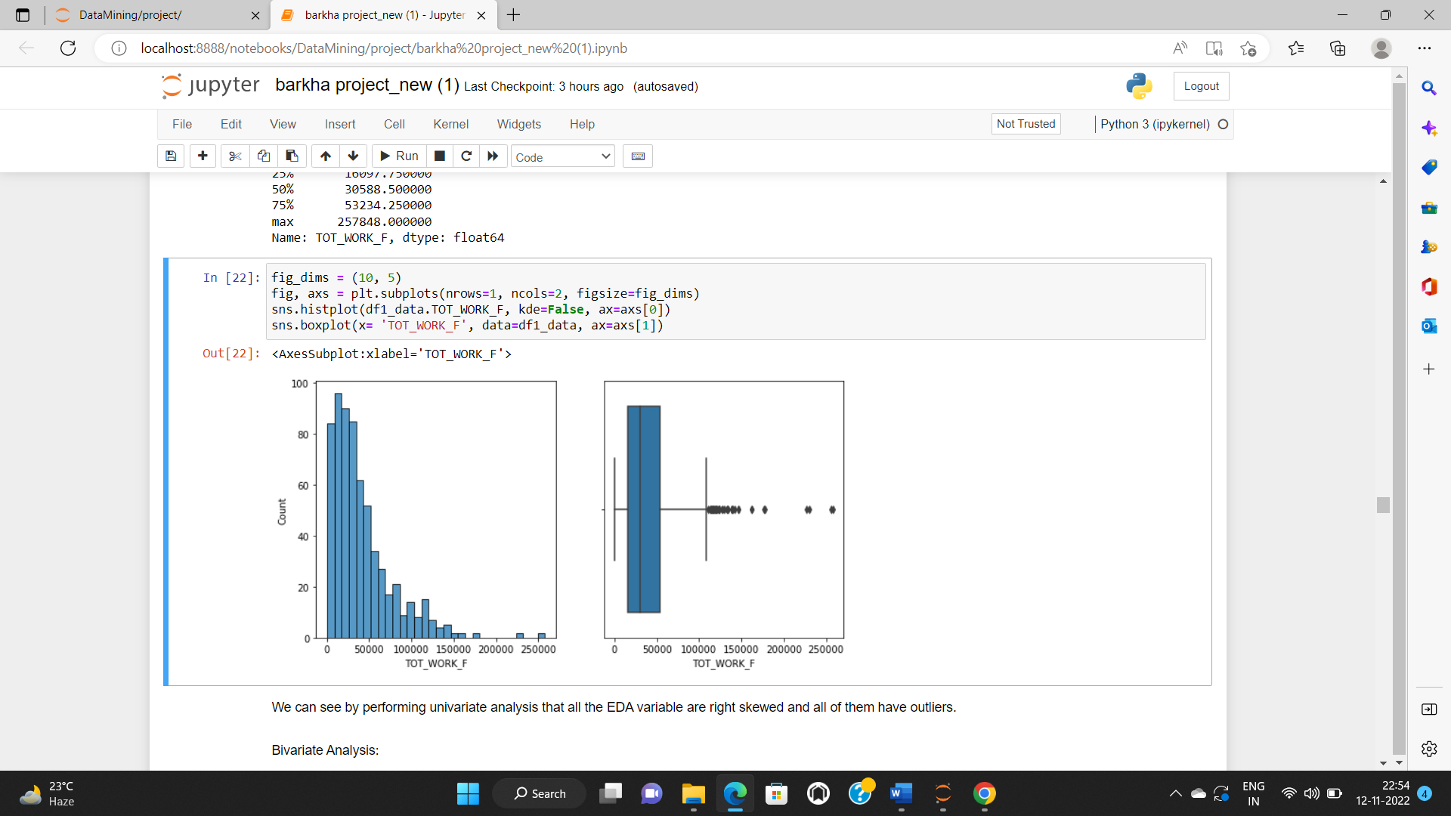

We can see by performing univariate analysis that all the EDA variable are right skewed and all of them have outliers.

Bivariate Analysis: Plotting scatterplot for all the variables.

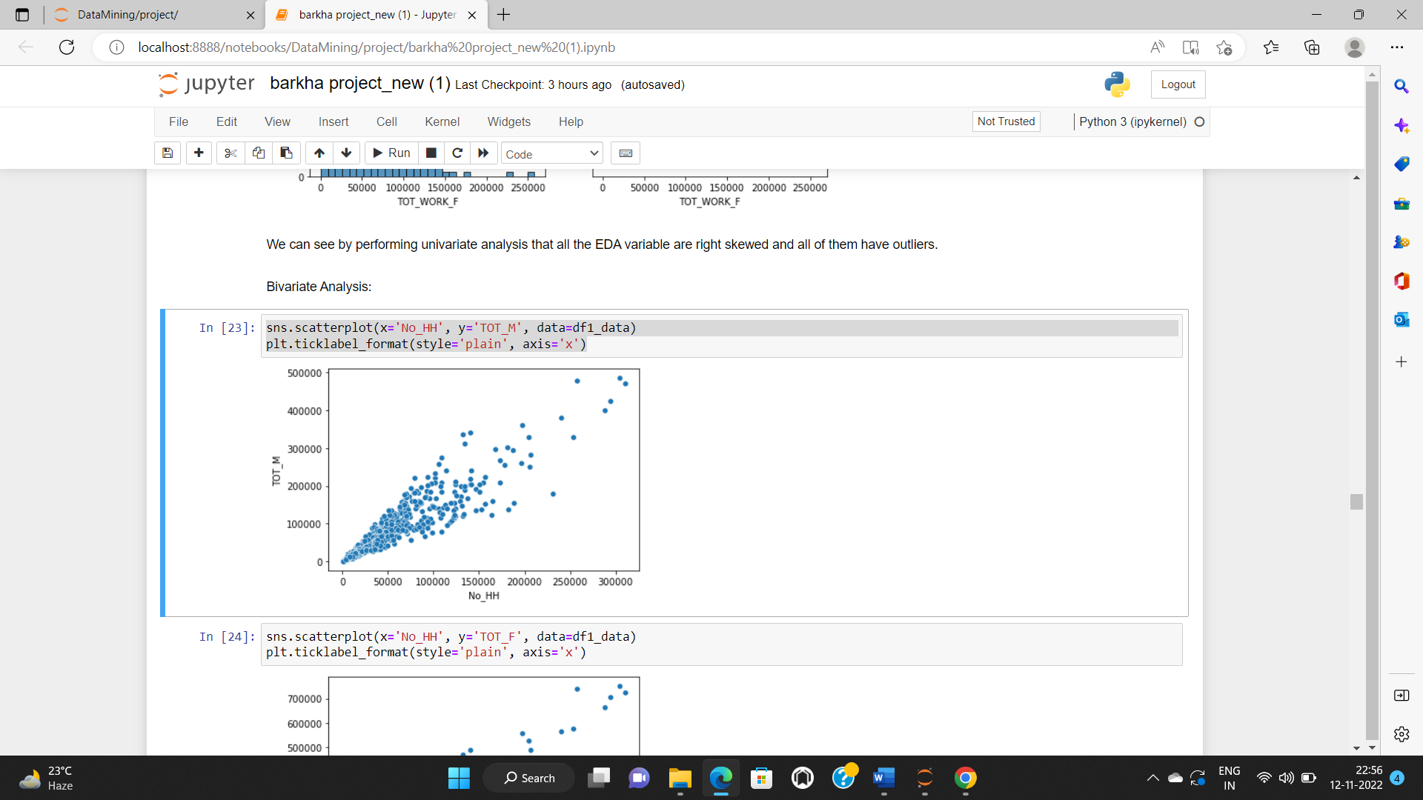

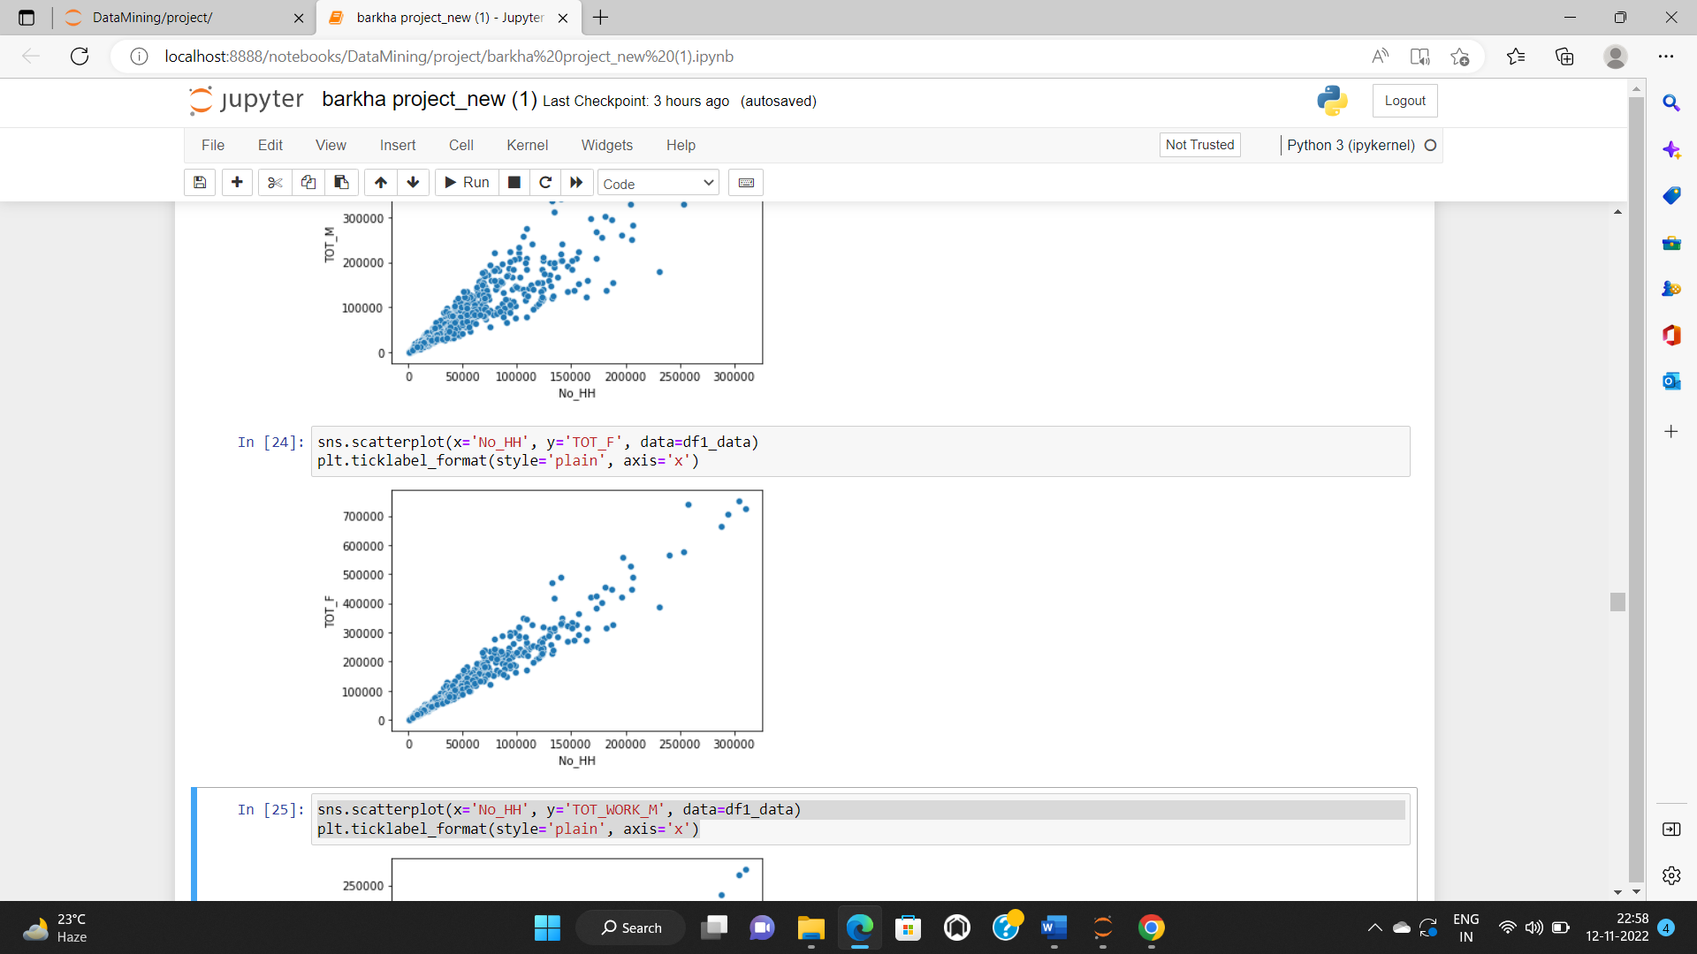

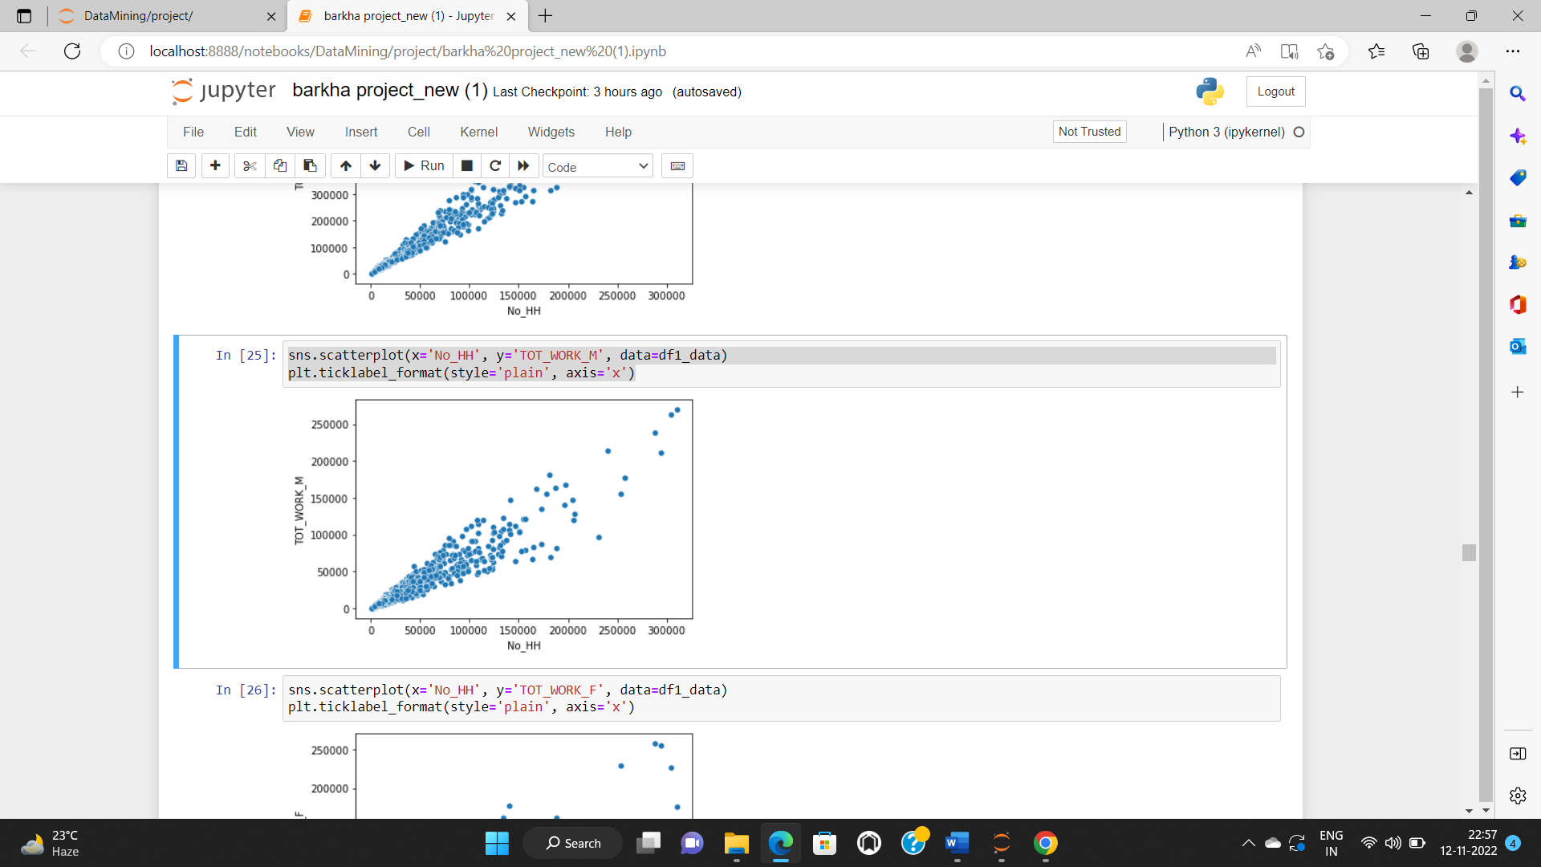

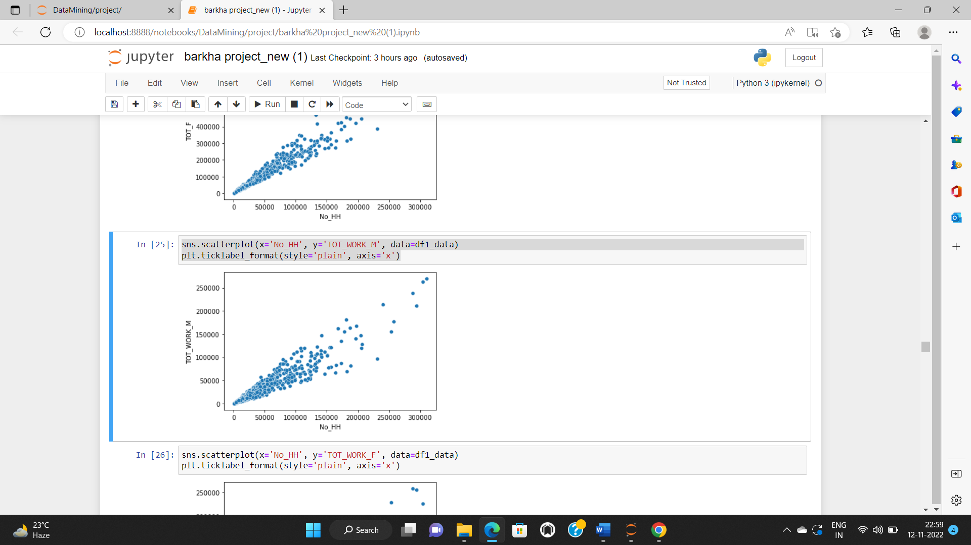

* **Part 2 - PCA: We choose not to treat outliers for this case. Do you think that treating outliers for this case is necessary?**

It is necessary to treat all the outliers in the data for PCA. Therefore, we will treat the outliers present in the data.

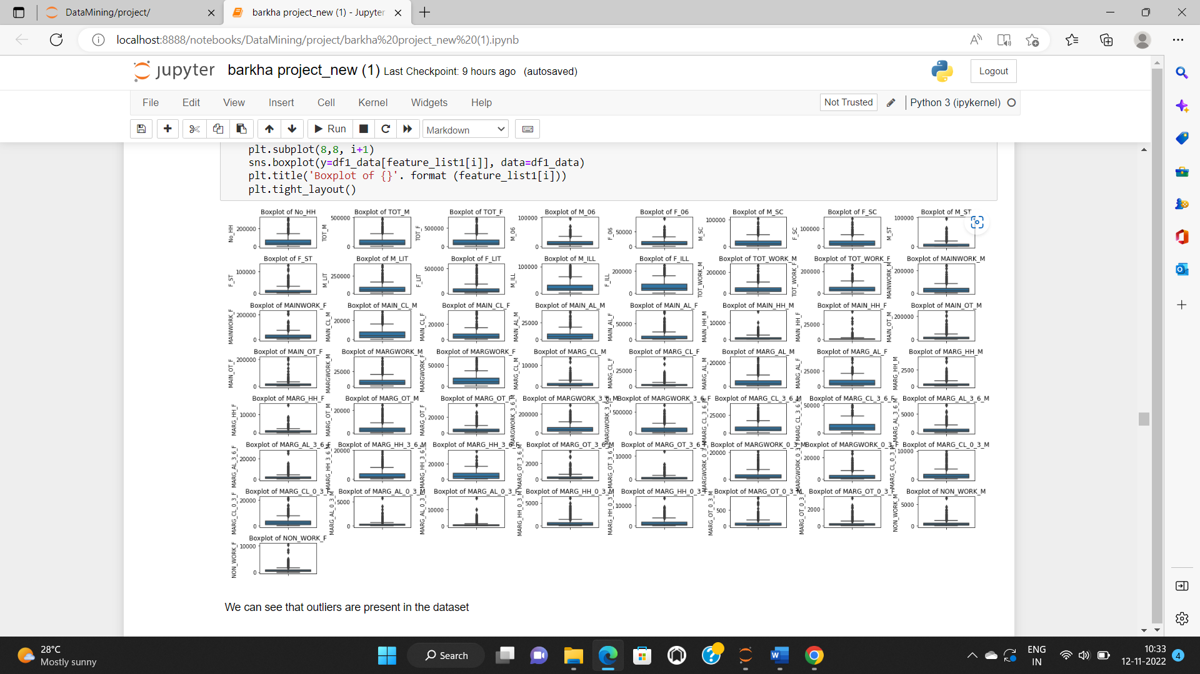

Boxplot after treating the outliers.

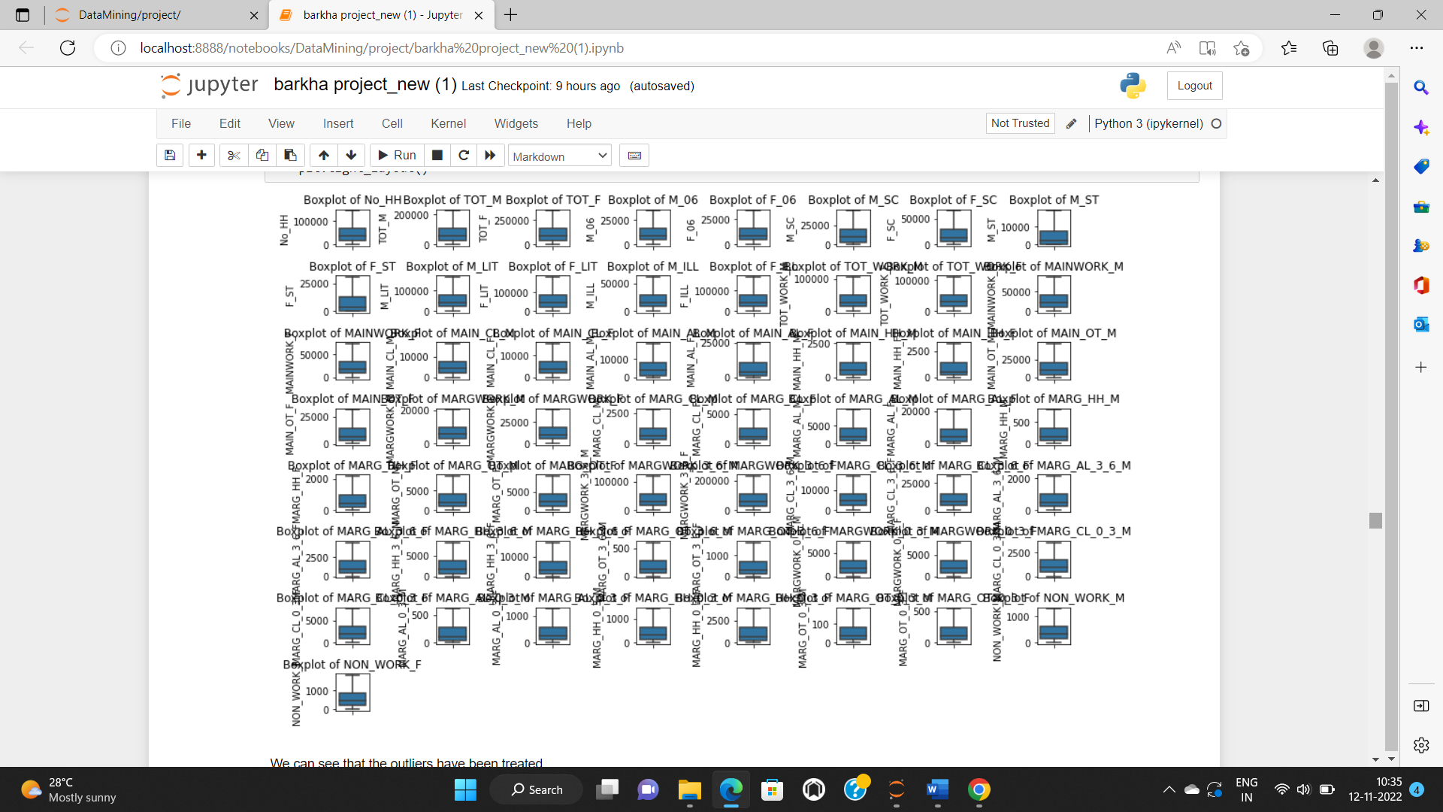

* **Part 2 - PCA: Scale the Data using z-score method. Does scaling have any impact on outliers? Compare boxplots before and after scaling and comment.**

In the original dataset there is a difference in the magnitude of data, so we want to bring the data in the same scale using z-score. This is another prerequisite for PCA. This will ensure that the data comes to standard normal form also known as standardization. Here, standard normal form means data will have a mean of 0 and standard deviation of 1, this is applicable for all the columns.

We will get a clear picture of the data before scaling the data.

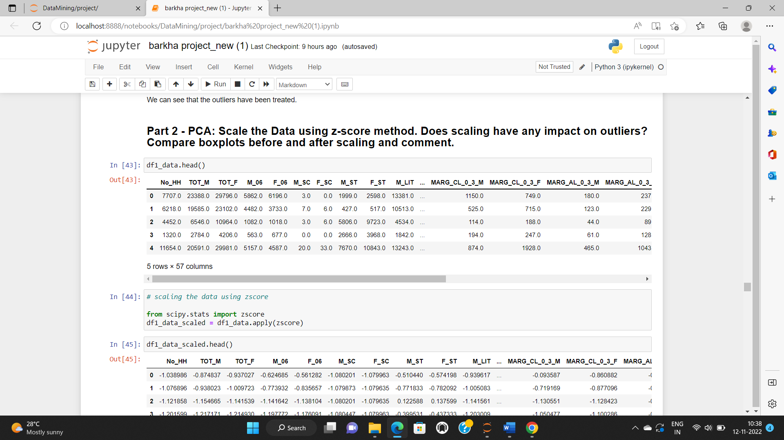

Below is the image attached after scaling the data.

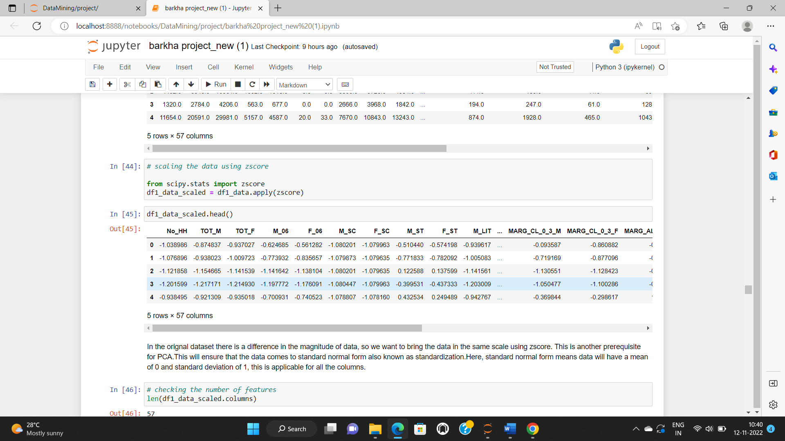

Now we will check the boxplot before scaling.

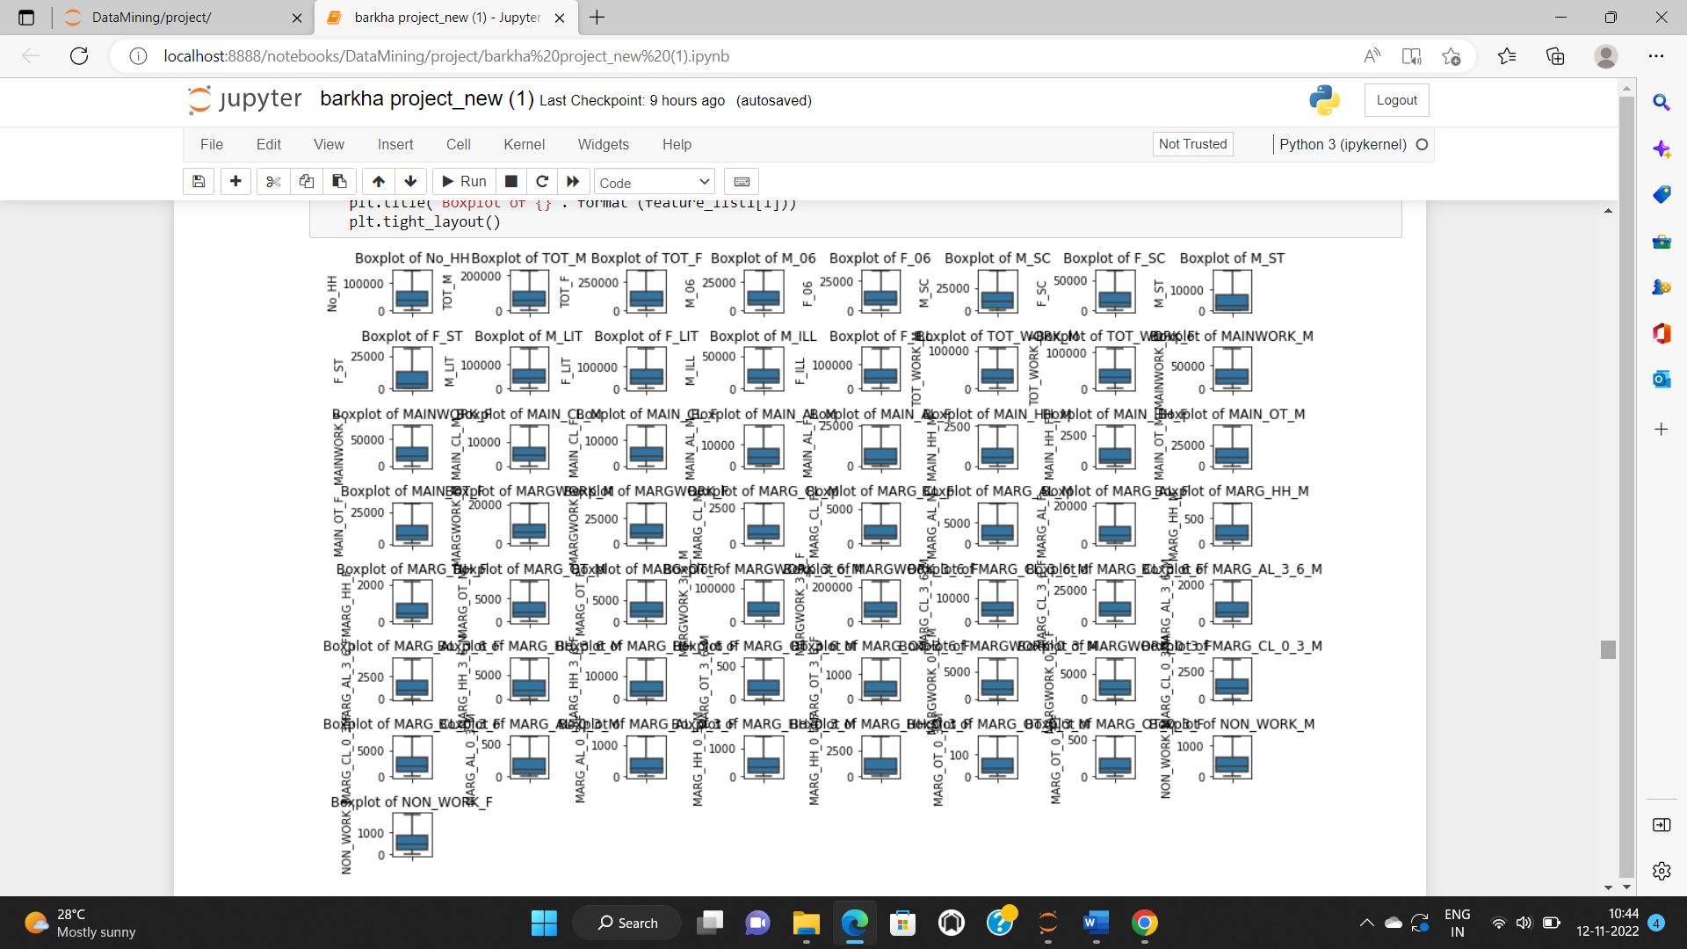

Boxplot after scaling the data.

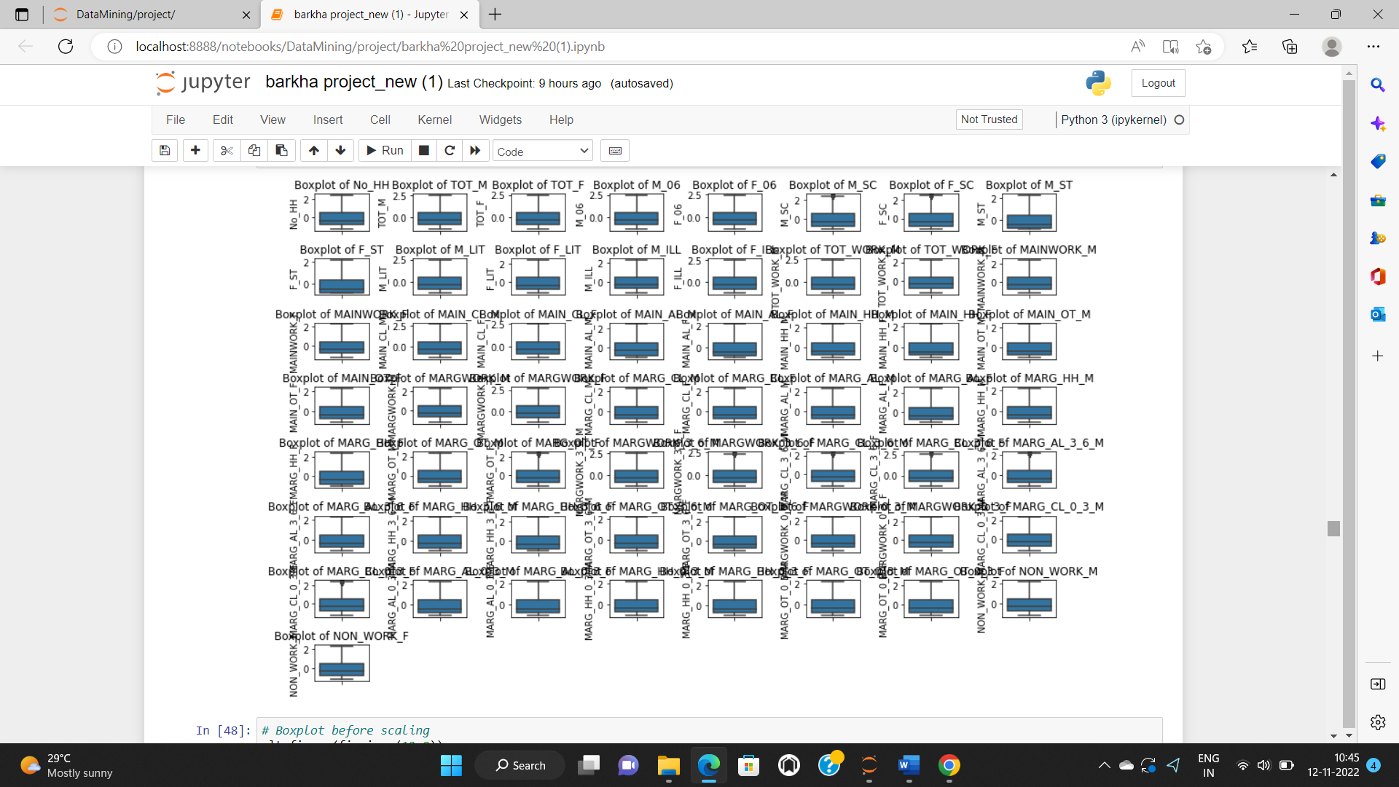

Here, we have shown the boxplots of data before and after scaling the data. We can see that there are no outliers in the data.

* **Part 2 - PCA: Perform all the required steps for PCA (use sklearn only) Create the covariance Matrix Get eigen values and eigen vector.**

Firstly, we will check the presence of correlation using a heatmap. Below image is the heatmap which shows that significant correlation exists.

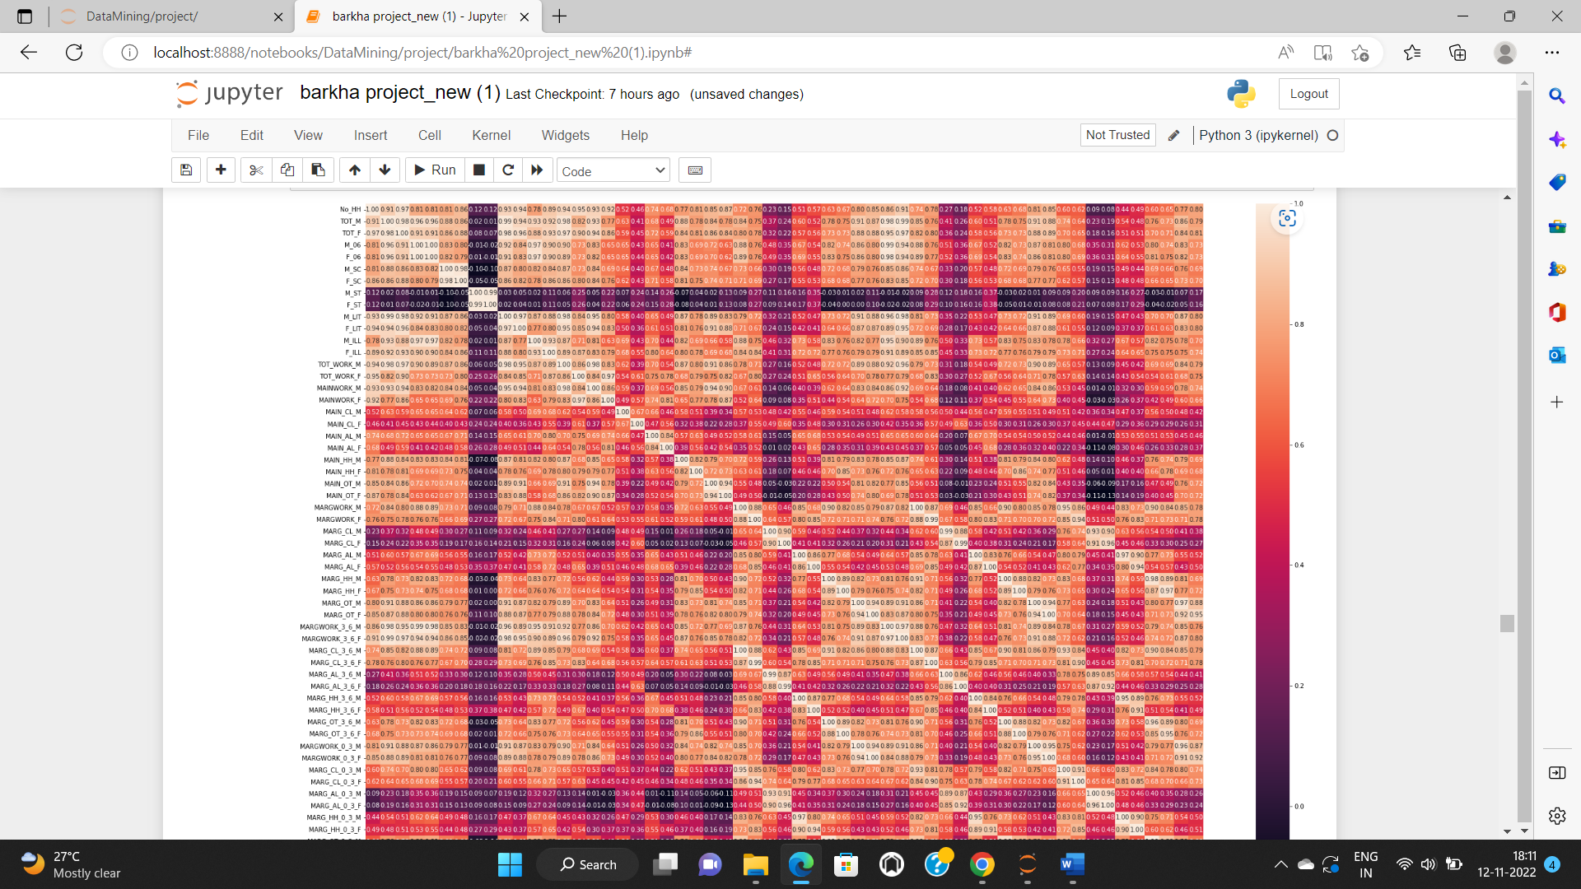

Secondly, we will confirm the statistical significance of correlations, where

H0: Correlations are not significant,

H1: There are significant correlations

Reject H0 if p-value < 0.05

Since here p-value is 0 which is less than 0.05 so we reject the null hypothesis and we can say that there are significant correlation.

Now, there is one more prerequisite which is the sample adequacy. By performing this we will have enough data to explore PCA. We should have multiple features for PCA. Here, we have sample adequacy 0.936 which is good and we can proceed with the analysis.

A very convenient way to do PCA is Scikit-learn, it is probably the most useful library for machine learning in Python. As we do not know how many components we want, we will assume it to be 12 in this case and random state to obtain the same results again and again.

Below attached are the coefficients also known as the eigen vectors. Once we have fit PCA, we will be able to extract the components. The components are one of the attributes of PCA.

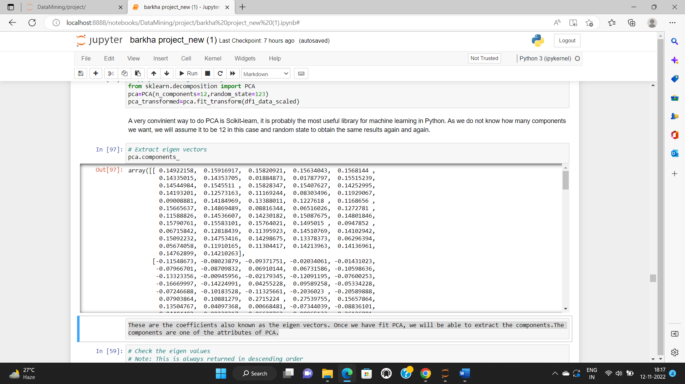

Now we will check the Eigen values. This is always in descending order.

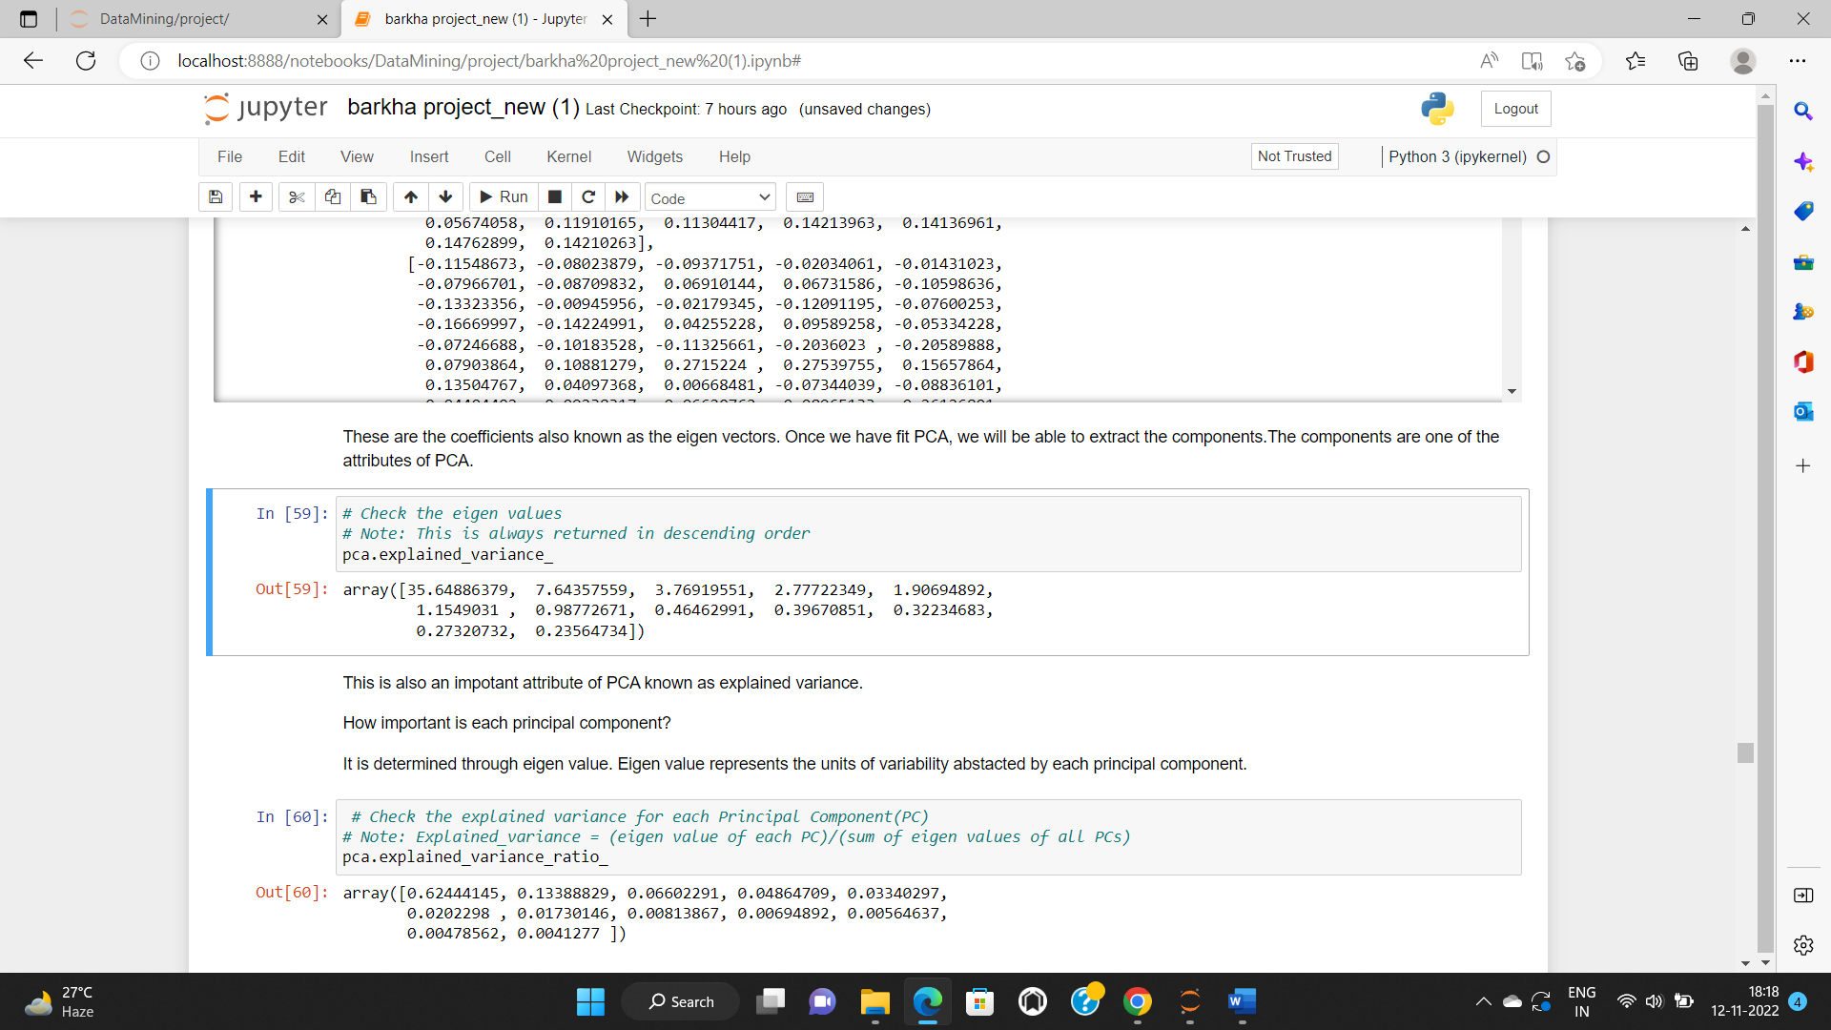

After getting the Eigen values, we will also check the explained variance of each principal component. This is also an important attribute of PCA known as explained variance.

Explained variance = (eigen value of each PC)/ (sum of eigen values of all PCs)

Below attached is the image of explained variance ratio.

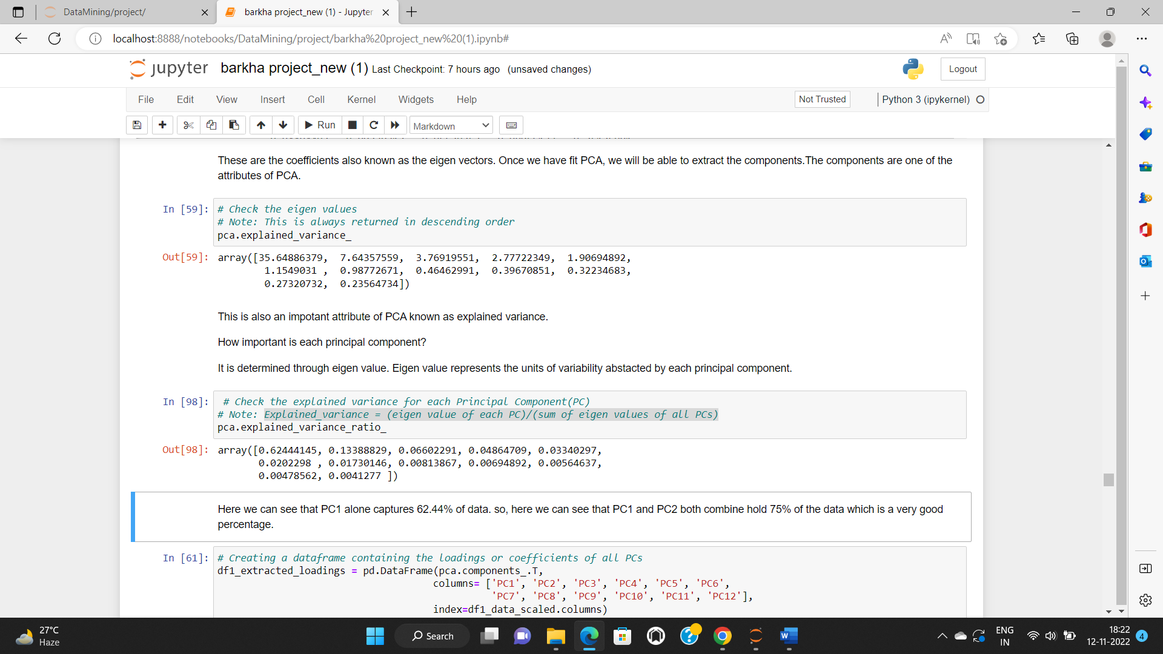

Here, we can see that PC1 alone captures 62.44% of data. so, here we can see that PC1 and PC2 both combine hold 75% of the data which is a very good percentage.

How important is each principal component?

It is determined through eigen value. Eigen value represents the units of variability abstracted by each principal component.

After all this we will create a data frame containing the loadings or coefficients of all PCs. Here we organize all in a data frame and try to look at it. We will take the transposed form of the data frame and we will name the columns, the indices here we use in the data frame will be name of the original features.

Below attached is the image of extracted loadings of original data.

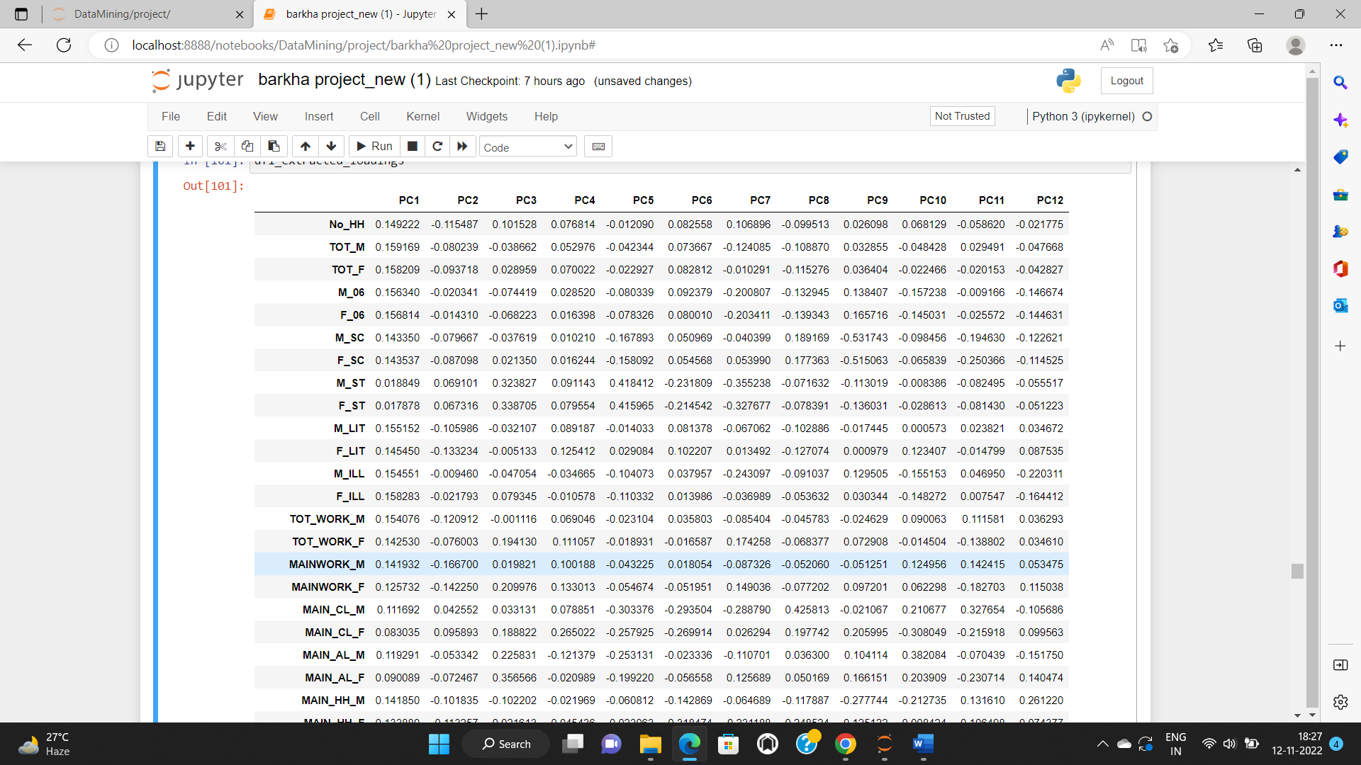

* **Part 2 - PCA: Identify the optimum number of PCs (for this project, take at least 90% explained variance). Show Scree plot.**

We create a scree plot to look at the explained variance ratio. It is a measure of relative importance of PC. The first PC would have the highest eigen value and the highest explained variance ratio also. This scree plot can be used to find out the relative number of principal components that we need. By watching this scree plot we can assume the number of components as we can see that maximum amount of data is captured in PC1 and PC2.

Below attached is the image of scree plot.

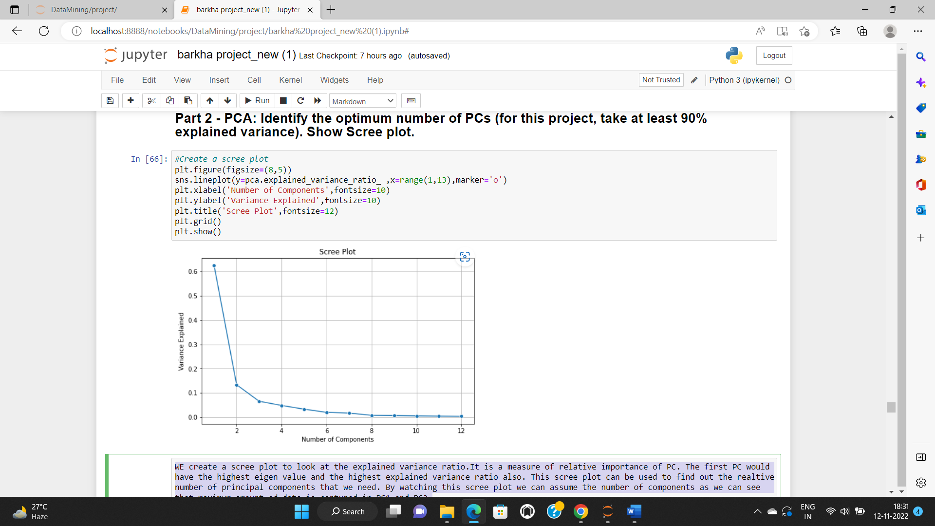

Now, we will check the cumulative explained variance ratio to find a cut off for selecting the number of PCs.

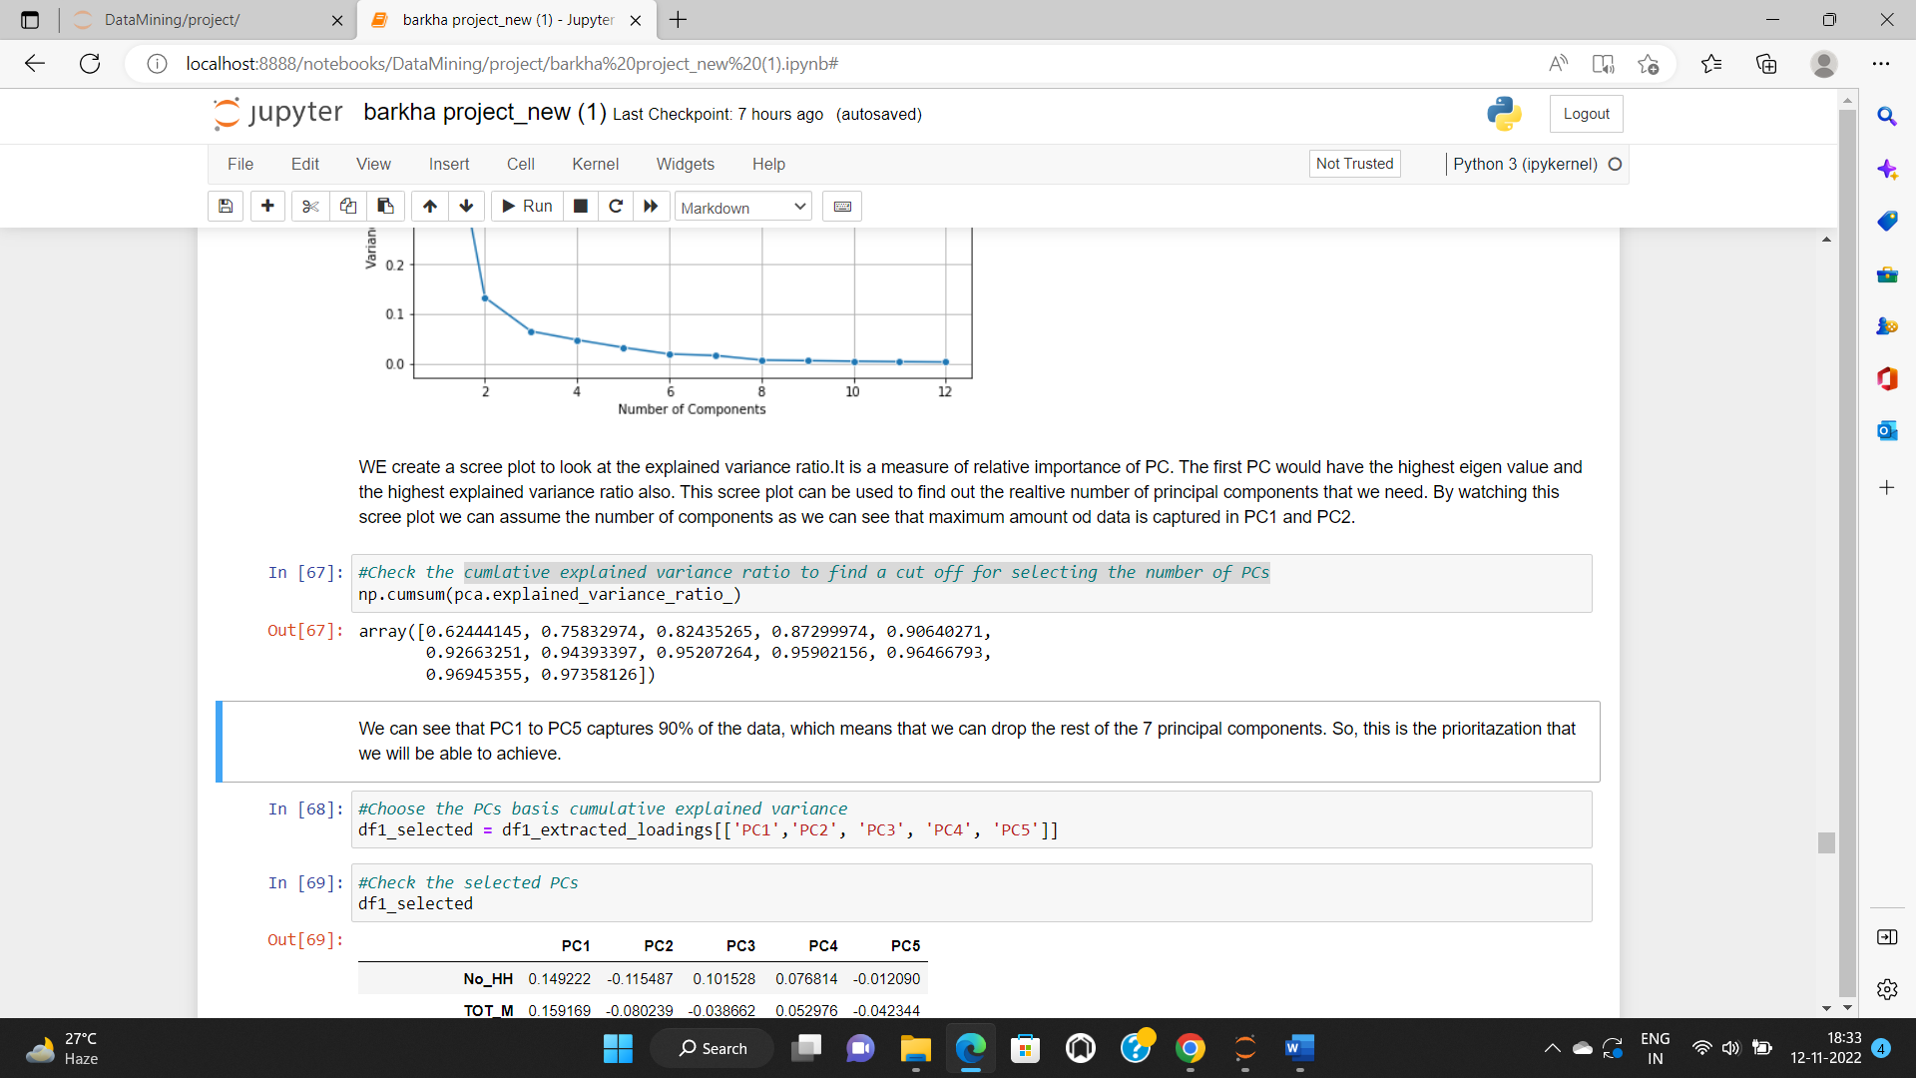

We can see that PC1 to PC5 captures 90% of the data, which means that we can drop the rest of the 7 principal components. So, this is the prioritization that we will be able to achieve.

After performing all this, we will select only the five principal components. Below attached is the image of the selected PCs.

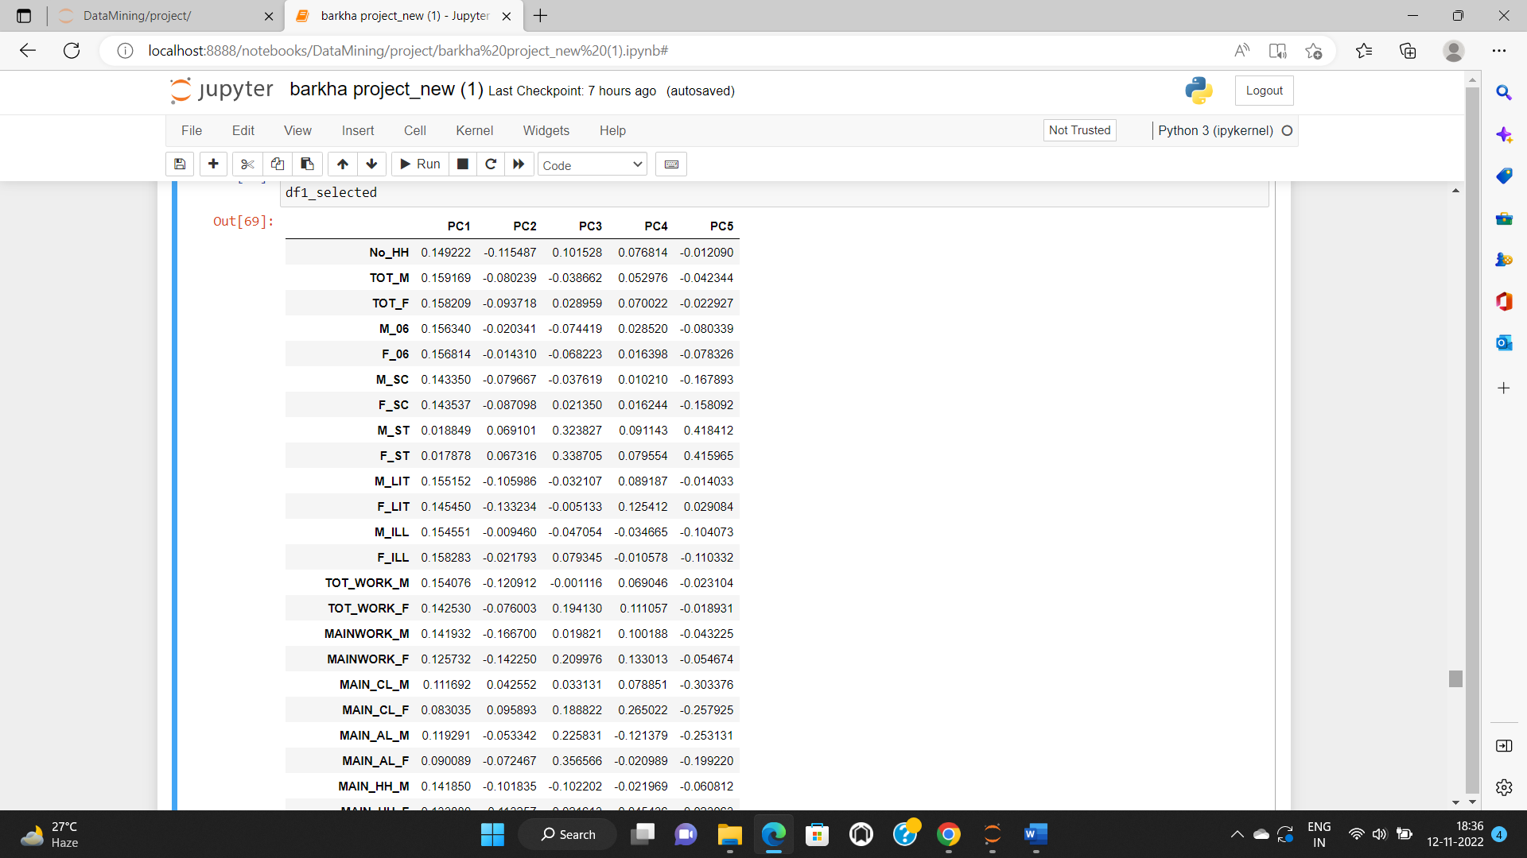

* **Part 2 - PCA: Compare PCs with Actual Columns and identify which is explaining most variance. Write inferences about all the Principal components in terms of actual variables.**

Here, as we are interested in the absolute values i.e; the magnitude rather than the positive and the negative values. Every PC has its own characteristics**.**

Below attached is the image of the selected PCs with the actual columns.

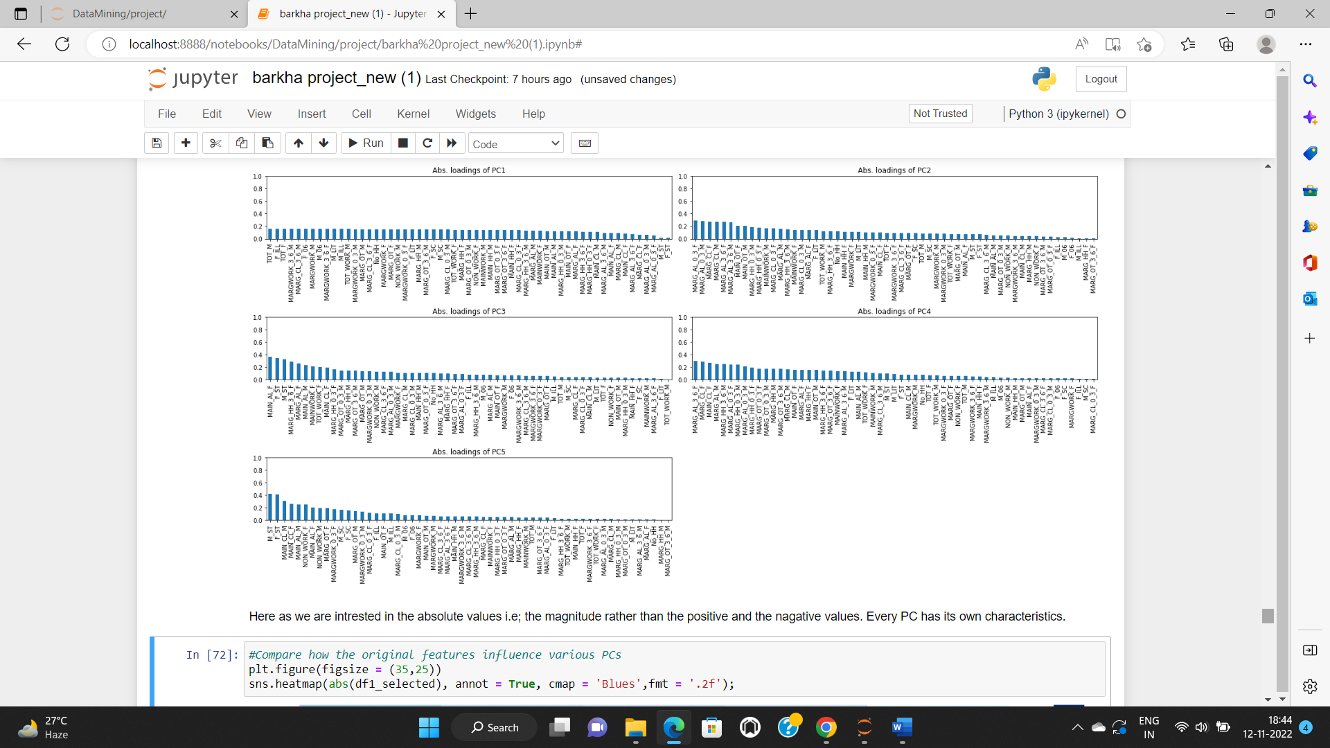

Now, we create a heatmap for the comparison of absolute values of the selected data. Below is the attached image of the heatmap showing the comparison.

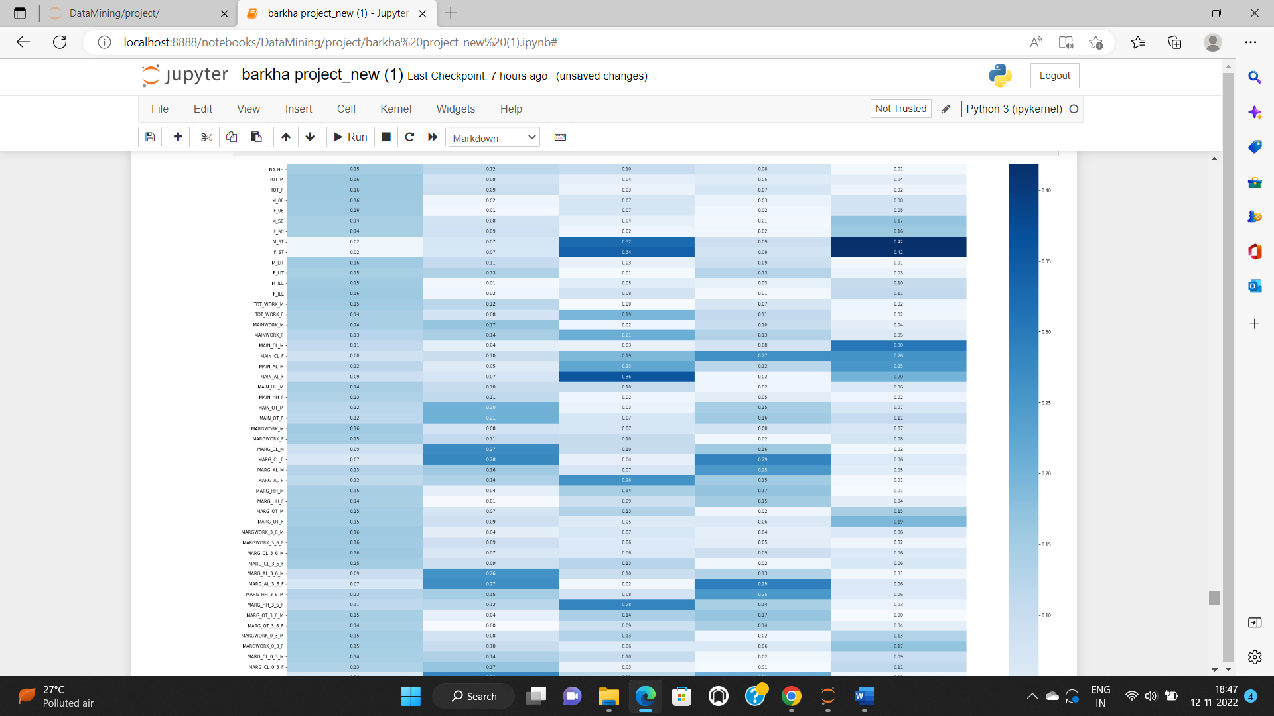

Now, we will calculate the PC scores and will perform a dot product between the loadings and features to obtain the scores.

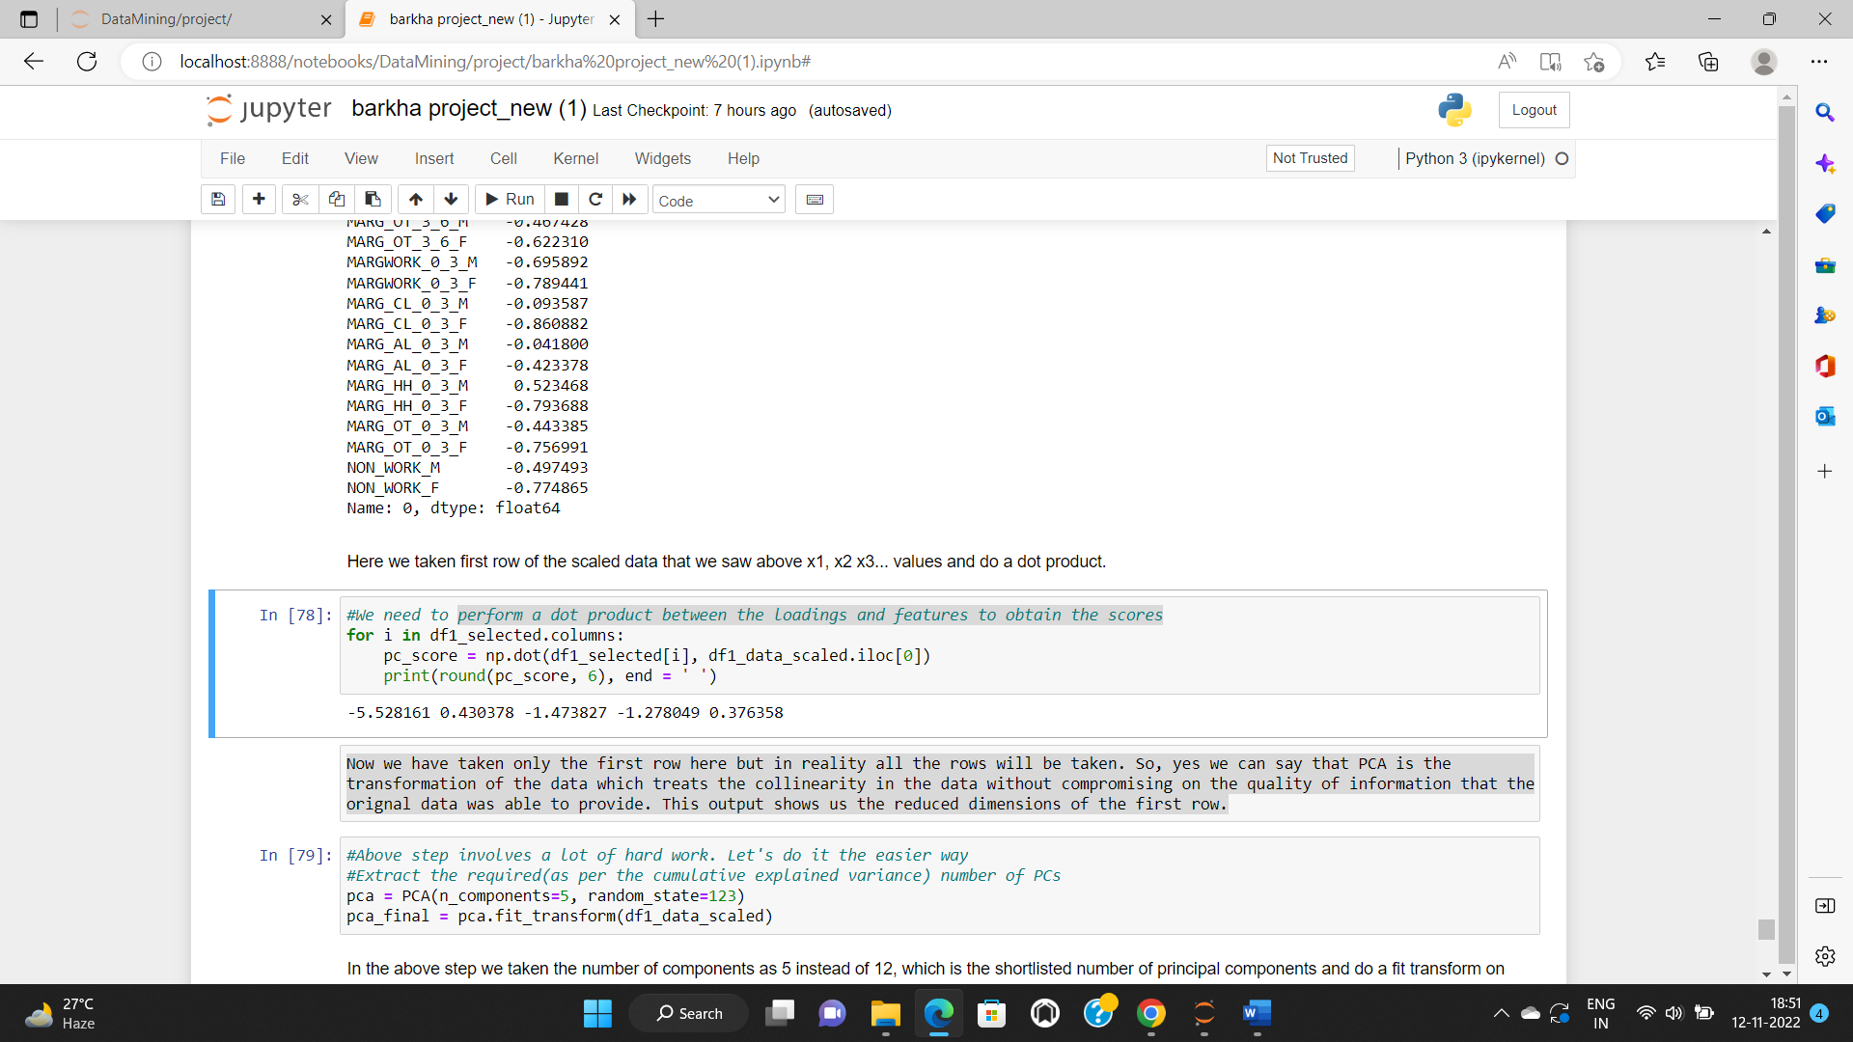

Now, we have taken only the first row here but in reality all the rows will be taken. So, yes, we can say that PCA is the transformation of the data which treats the collinearity in the data without compromising on the quality of information that the original data was able to provide. This output shows us the reduced dimensions of the first row.

We will just create a data frame out of fit transformed scaled data.

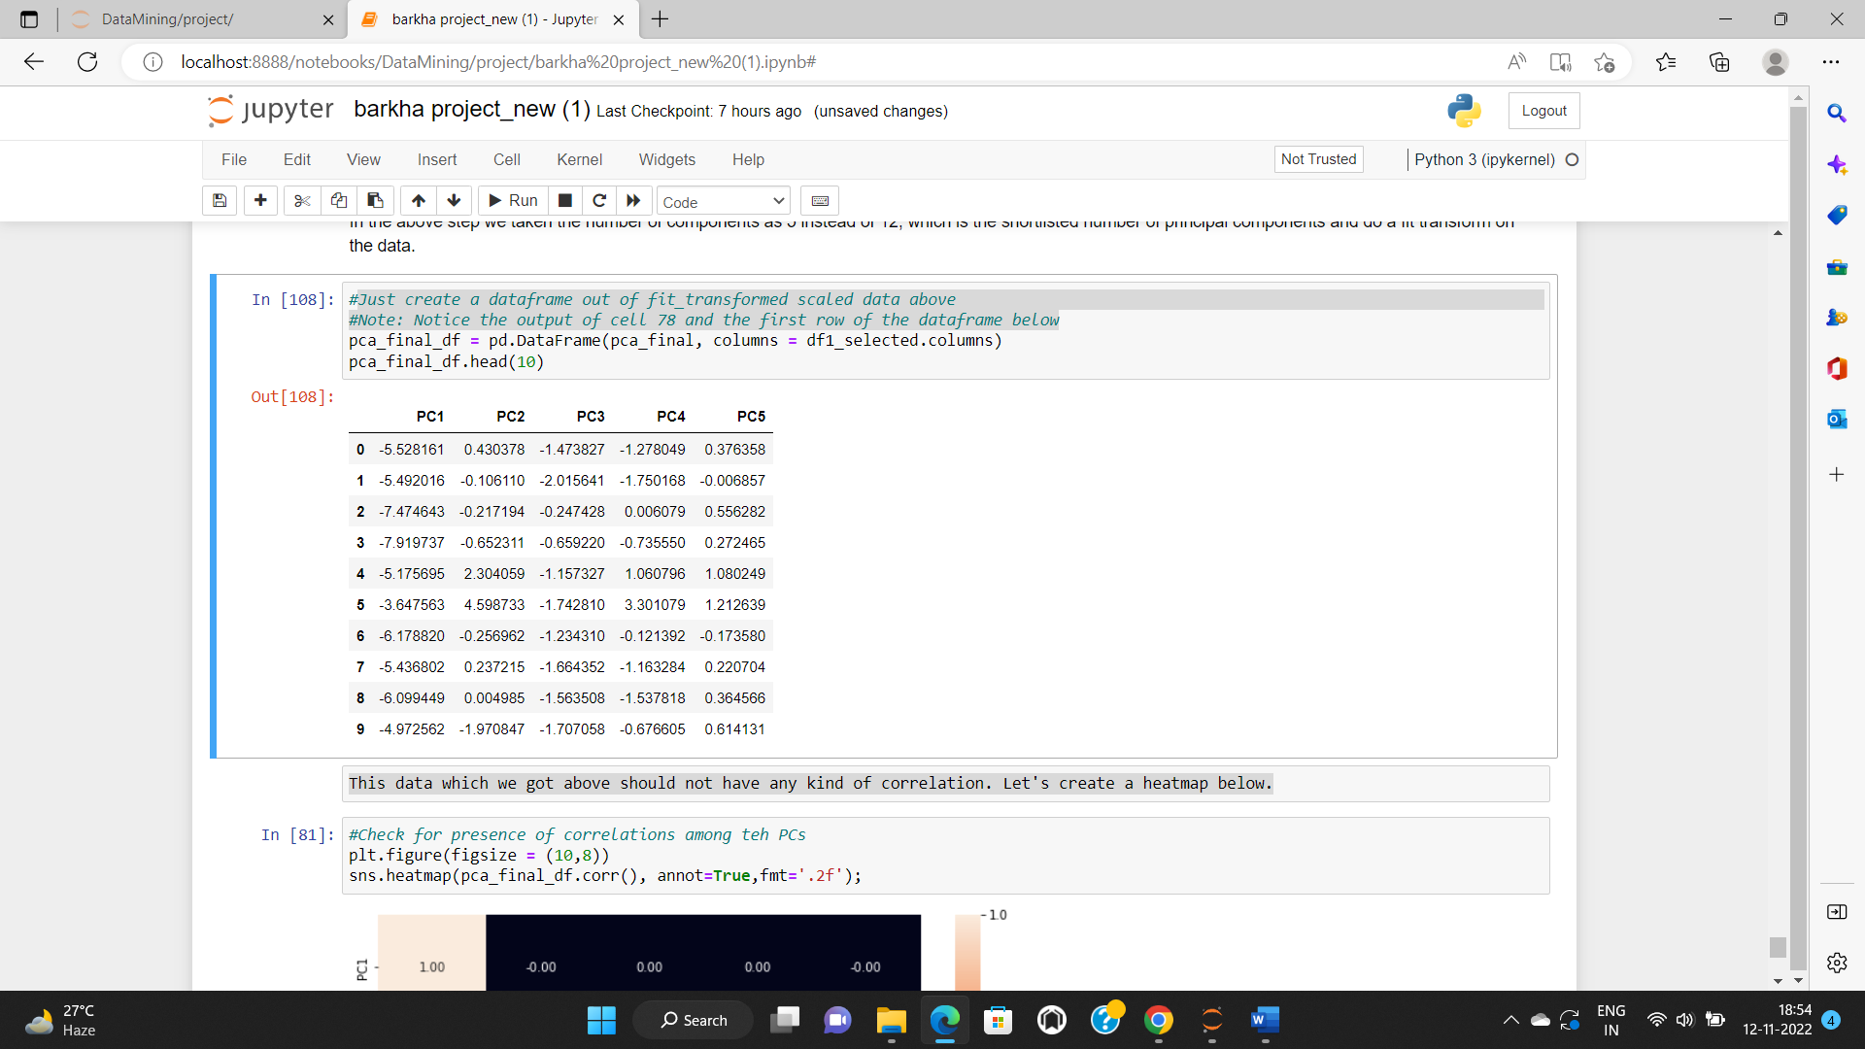

This data which we got above should not have any kind of correlation. Let's create a heatmap below.

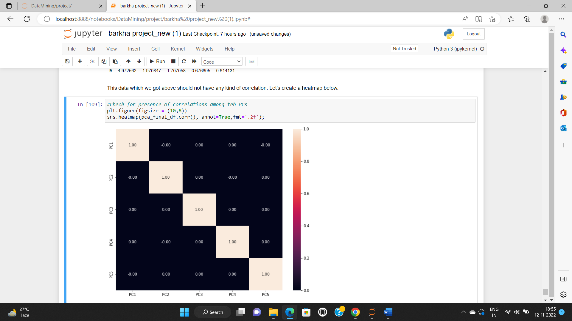

So, here we can see that we do not have any correlation in the variables.

* **Part 2 - PCA: Write linear equation for first PC.**

PC1 = a1x1 + a2x2 + a3X3 +a4X4 + ……. + a57x57

PCA1= (0.149222)*(-1.038986) + (0.159169)*(-0.874837)……….+ ( 0.142103)*

( -0.774865)